Laporan Praktikum
Bahasa Pemrograman 1
Dosen pengampu : (Dede Husen, M.Kom.)

Modul 7 & 8



Nama : Muhammad Rizal Nurfirdaus
NIM : 20230810088
Kelas : TINFC – 2023 – 04

Teknik Informatika Fakultas Ilmu Komputer
Universitas Kuningan
Modul 7
PreTest
- Tulis dan jelaskan dengan singkat komponen dari JDBC API!
JDBC API terdiri dari beberapa komponen utama untuk mengelola koneksi dan operasi database. DriverManager mengelola driver database dan membuat Connection untuk menghubungkan aplikasi ke database. Statement digunakan untuk menjalankan perintah SQL statis, sedangkan PreparedStatement memungkinkan eksekusi query dengan parameter, lebih aman terhadap SQL Injection. Hasil query disimpan dalam ResultSet, yang memungkinkan pembacaan data baris demi baris. SQLException menangkap kesalahan yang terjadi selama operasi database. Alternatifnya, DataSource menyediakan manajemen koneksi dengan pooling untuk aplikasi skala besar, membuat proses lebih efisien. Komponen-komponen ini saling terhubung untuk memudahkan pengelolaan data di aplikasi Java.
Praktikum

/*
* To change this license header, choose License Headers in Project Properties.
* To change this template file, choose Tools | Templates
* and open the template in the editor.
*/

package bp1_m6_rizal;

import java.sql.ResultSet;
import java.sql.SQLException;
import java.sql.Statement;
import javax.swing.JOptionPane;
import javax.swing.table.DefaultTableModel;

/**
*
* @author Muhammad Rizal Nur F
*/
public class BP1_M6_P1_Rizal extends javax.swing.JFrame {
private Object JTable1;

Statement st;
ResultSet rs;
koneksi koneksi;

/**
* Creates new form BP1_M6_P1_Rizal
*/
public BP1_M6_P1_Rizal() {
koneksi = new koneksi();
initComponents();
load_data();
}
private void load_data(){
Object header []={"NIM","NAMA","JENIS KELAMIN","PRODI","ALAMAT"};
DefaultTableModel data = new DefaultTableModel(null,header);
jTable1.setModel(data);
String sql="SELECT nim, nama, jk, prodi, alamat FROM tabel_mhs";
try{
st = koneksi.con.createStatement();
rs = st.executeQuery(sql);
while (rs.next()) {
String k1 = rs.getString("nim");
String k2 = rs.getString("nama");
String k3 = rs.getString("jk");
String k4 = rs.getString("prodi");
String k5 = rs.getString("alamat");

String k[] = {k1, k2, k3, k4, k5};
data.addRow(k);
}
}
catch(Exception e){
JOptionPane.showMessageDialog(null, e);
}
}
public void input_data() {
try {
String jk; // Gender or some similar attribute (assuming)
if (jRadioButton1.isSelected()) {
jk = jRadioButton1.getText(); // Fix the reference to jRadioButton1
} else {
jk = jRadioButton2.getText(); // Fix the reference to jRadioButton2
}

// Prepare the SQL query
String sql = "INSERT INTO mhs (column1, column2, column3, column4, column5) VALUES ('"
+ jTextField1.getText() + "', '"
+ jTextField2.getText() + "', '"
+ jk + "', '"
+ jComboBox1.getSelectedItem().toString() + "', '"
+ jTextArea1.getText() + "')";

// Execute the SQL statement
st.execute(sql);
JOptionPane.showMessageDialog(null, "Data Mahasiswa Berhasil Di Input");
}
catch (SQLException e) {
JOptionPane.showMessageDialog(null, "Error: " + e.getMessage());
}
}
/**
* This method is called from within the constructor to initialize the form.
* WARNING: Do NOT modify this code. The content of this method is always
* regenerated by the Form Editor.
*/
@SuppressWarnings("unchecked")
// <editor-fold defaultstate="collapsed" desc="Generated Code">
private void initComponents() {

jLabel1 = new javax.swing.JLabel();
jLabel2 = new javax.swing.JLabel();
jLabel3 = new javax.swing.JLabel();
jLabel4 = new javax.swing.JLabel();
jLabel5 = new javax.swing.JLabel();
jLabel6 = new javax.swing.JLabel();
jLabel7 = new javax.swing.JLabel();
jLabel8 = new javax.swing.JLabel();
jTextField1 = new javax.swing.JTextField();
jTextField2 = new javax.swing.JTextField();
jRadioButton1 = new javax.swing.JRadioButton();
jRadioButton2 = new javax.swing.JRadioButton();
jComboBox1 = new javax.swing.JComboBox();
jScrollPane1 = new javax.swing.JScrollPane();
jTextArea1 = new javax.swing.JTextArea();
jButton1 = new javax.swing.JButton();
jButton2 = new javax.swing.JButton();
jButton3 = new javax.swing.JButton();
jScrollPane2 = new javax.swing.JScrollPane();
jTable1 = new javax.swing.JTable();

setDefaultCloseOperation(javax.swing.WindowConstants.EXIT_ON_CLOSE);

jLabel1.setText("DATA MAHASISWA");

jLabel2.setText("FORM INPUT DATA ");

jLabel3.setText("DATA MAHASISWA");

jLabel4.setText("NIM");

jLabel5.setText("NAMA");

jLabel6.setText("JENIS KELAMIN");

jLabel7.setText("PRODI");

jLabel8.setText("ALAMAT");

jTextField1.addActionListener(new java.awt.event.ActionListener() {
public void actionPerformed(java.awt.event.ActionEvent evt) {
jTextField1ActionPerformed(evt);
}
});

jRadioButton1.setText("L");

jRadioButton2.setText("p");

jComboBox1.setModel(new javax.swing.DefaultComboBoxModel(new String[] { "TI", "SI", "DKV", "MI", "TS" }));

jTextArea1.setColumns(20);
jTextArea1.setRows(5);
jScrollPane1.setViewportView(jTextArea1);

jButton1.setText("SIMPAN");

jButton2.setText("EDIT");

jButton3.setText("HAPUS");

jTable1.setModel(new javax.swing.table.DefaultTableModel(
new Object [][] {
{null, null, null, null},
{null, null, null, null},
{null, null, null, null},
{null, null, null, null}
},
new String [] {
"Title 1", "Title 2", "Title 3", "Title 4"
}
));
jScrollPane2.setViewportView(jTable1);

javax.swing.GroupLayout layout = new javax.swing.GroupLayout(getContentPane());
getContentPane().setLayout(layout);
layout.setHorizontalGroup(
layout.createParallelGroup(javax.swing.GroupLayout.Alignment.LEADING)
.addGroup(layout.createSequentialGroup()
.addContainerGap()
.addGroup(layout.createParallelGroup(javax.swing.GroupLayout.Alignment.LEADING)
.addGroup(layout.createSequentialGroup()
.addGroup(layout.createParallelGroup(javax.swing.GroupLayout.Alignment.LEADING)
.addComponent(jLabel4)
.addComponent(jLabel5)
.addComponent(jLabel6)
.addComponent(jLabel7)
.addComponent(jLabel8))
.addGap(38, 38, 38)
.addGroup(layout.createParallelGroup(javax.swing.GroupLayout.Alignment.LEADING)
.addGroup(layout.createParallelGroup(javax.swing.GroupLayout.Alignment.LEADING, false)
.addComponent(jTextField1)
.addComponent(jTextField2, javax.swing.GroupLayout.DEFAULT_SIZE, 210, Short.MAX_VALUE))
.addComponent(jLabel2)
.addGroup(layout.createSequentialGroup()
.addComponent(jRadioButton1)
.addPreferredGap(javax.swing.LayoutStyle.ComponentPlacement.UNRELATED)
.addComponent(jRadioButton2))
.addComponent(jComboBox1, javax.swing.GroupLayout.PREFERRED_SIZE, javax.swing.GroupLayout.DEFAULT_SIZE, javax.swing.GroupLayout.PREFERRED_SIZE)
.addComponent(jScrollPane1, javax.swing.GroupLayout.PREFERRED_SIZE, javax.swing.GroupLayout.DEFAULT_SIZE, javax.swing.GroupLayout.PREFERRED_SIZE)
.addGroup(layout.createSequentialGroup()
.addComponent(jButton1)
.addPreferredGap(javax.swing.LayoutStyle.ComponentPlacement.UNRELATED)
.addComponent(jButton2)
.addGap(18, 18, 18)
.addComponent(jButton3)))
.addGroup(layout.createParallelGroup(javax.swing.GroupLayout.Alignment.LEADING)
.addGroup(layout.createSequentialGroup()
.addPreferredGap(javax.swing.LayoutStyle.ComponentPlacement.RELATED, javax.swing.GroupLayout.DEFAULT_SIZE, Short.MAX_VALUE)
.addComponent(jLabel3)
.addGap(188, 188, 188))
.addGroup(layout.createSequentialGroup()
.addGap(18, 18, 18)
.addComponent(jScrollPane2, javax.swing.GroupLayout.PREFERRED_SIZE, javax.swing.GroupLayout.DEFAULT_SIZE, javax.swing.GroupLayout.PREFERRED_SIZE)
.addContainerGap(javax.swing.GroupLayout.DEFAULT_SIZE, Short.MAX_VALUE))))
.addGroup(javax.swing.GroupLayout.Alignment.TRAILING, layout.createSequentialGroup()
.addGap(0, 0, Short.MAX_VALUE)
.addComponent(jLabel1)
.addGap(422, 422, 422))))
);
layout.setVerticalGroup(
layout.createParallelGroup(javax.swing.GroupLayout.Alignment.LEADING)
.addGroup(layout.createSequentialGroup()
.addContainerGap()
.addComponent(jLabel1)
.addGap(18, 18, 18)
.addGroup(layout.createParallelGroup(javax.swing.GroupLayout.Alignment.BASELINE)
.addComponent(jLabel2)
.addComponent(jLabel3))
.addPreferredGap(javax.swing.LayoutStyle.ComponentPlacement.RELATED)
.addGroup(layout.createParallelGroup(javax.swing.GroupLayout.Alignment.LEADING)
.addGroup(layout.createSequentialGroup()
.addGroup(layout.createParallelGroup(javax.swing.GroupLayout.Alignment.LEADING)
.addComponent(jLabel4)
.addComponent(jTextField1, javax.swing.GroupLayout.PREFERRED_SIZE, javax.swing.GroupLayout.DEFAULT_SIZE, javax.swing.GroupLayout.PREFERRED_SIZE))
.addGap(18, 18, 18)
.addGroup(layout.createParallelGroup(javax.swing.GroupLayout.Alignment.BASELINE)
.addComponent(jLabel5)
.addComponent(jTextField2, javax.swing.GroupLayout.PREFERRED_SIZE, javax.swing.GroupLayout.DEFAULT_SIZE, javax.swing.GroupLayout.PREFERRED_SIZE))
.addGap(34, 34, 34)
.addGroup(layout.createParallelGroup(javax.swing.GroupLayout.Alignment.BASELINE)
.addComponent(jLabel6)
.addComponent(jRadioButton1)
.addComponent(jRadioButton2))
.addGap(67, 67, 67)
.addGroup(layout.createParallelGroup(javax.swing.GroupLayout.Alignment.BASELINE)
.addComponent(jLabel7)
.addComponent(jComboBox1, javax.swing.GroupLayout.PREFERRED_SIZE, javax.swing.GroupLayout.DEFAULT_SIZE, javax.swing.GroupLayout.PREFERRED_SIZE))
.addGap(25, 25, 25)
.addGroup(layout.createParallelGroup(javax.swing.GroupLayout.Alignment.LEADING)
.addComponent(jLabel8)
.addComponent(jScrollPane1, javax.swing.GroupLayout.PREFERRED_SIZE, javax.swing.GroupLayout.DEFAULT_SIZE, javax.swing.GroupLayout.PREFERRED_SIZE))
.addGap(18, 18, 18)
.addGroup(layout.createParallelGroup(javax.swing.GroupLayout.Alignment.BASELINE)
.addComponent(jButton1)
.addComponent(jButton2)
.addComponent(jButton3)))
.addComponent(jScrollPane2, javax.swing.GroupLayout.PREFERRED_SIZE, javax.swing.GroupLayout.DEFAULT_SIZE, javax.swing.GroupLayout.PREFERRED_SIZE))
.addContainerGap(41, Short.MAX_VALUE))
);

pack();
}// </editor-fold>

private void jTextField1ActionPerformed(java.awt.event.ActionEvent evt) {
// TODO add your handling code here:
}

/**
* @param args the command line arguments
*/
public static void main(String args[]) {
/* Set the Nimbus look and feel */
//<editor-fold defaultstate="collapsed" desc=" Look and feel setting code (optional) ">
/* If Nimbus (introduced in Java SE 6) is not available, stay with the default look and feel.
* For details see http://download.oracle.com/javase/tutorial/uiswing/lookandfeel/plaf.html
*/
try {
for (javax.swing.UIManager.LookAndFeelInfo info : javax.swing.UIManager.getInstalledLookAndFeels()) {
if ("Nimbus".equals(info.getName())) {
javax.swing.UIManager.setLookAndFeel(info.getClassName());
break;
}
}
} catch (ClassNotFoundException ex) {
java.util.logging.Logger.getLogger(BP1_M6_P1_Rizal.class.getName()).log(java.util.logging.Level.SEVERE, null, ex);
} catch (InstantiationException ex) {
java.util.logging.Logger.getLogger(BP1_M6_P1_Rizal.class.getName()).log(java.util.logging.Level.SEVERE, null, ex);
} catch (IllegalAccessException ex) {
java.util.logging.Logger.getLogger(BP1_M6_P1_Rizal.class.getName()).log(java.util.logging.Level.SEVERE, null, ex);
} catch (javax.swing.UnsupportedLookAndFeelException ex) {
java.util.logging.Logger.getLogger(BP1_M6_P1_Rizal.class.getName()).log(java.util.logging.Level.SEVERE, null, ex);
}
//</editor-fold>

/* Create and display the form */
java.awt.EventQueue.invokeLater(new Runnable() {
public void run() {
new BP1_M6_P1_Rizal().setVisible(true);
}
});
}

// Variables declaration - do not modify
private javax.swing.JButton jButton1;
private javax.swing.JButton jButton2;
private javax.swing.JButton jButton3;
private javax.swing.JComboBox jComboBox1;
private javax.swing.JLabel jLabel1;
private javax.swing.JLabel jLabel2;
private javax.swing.JLabel jLabel3;
private javax.swing.JLabel jLabel4;
private javax.swing.JLabel jLabel5;
private javax.swing.JLabel jLabel6;
private javax.swing.JLabel jLabel7;
private javax.swing.JLabel jLabel8;
private javax.swing.JRadioButton jRadioButton1;
private javax.swing.JRadioButton jRadioButton2;
private javax.swing.JScrollPane jScrollPane1;
private javax.swing.JScrollPane jScrollPane2;
private javax.swing.JTable jTable1;
private javax.swing.JTextArea jTextArea1;
private javax.swing.JTextField jTextField1;
private javax.swing.JTextField jTextField2;
// End of variables declaration
}
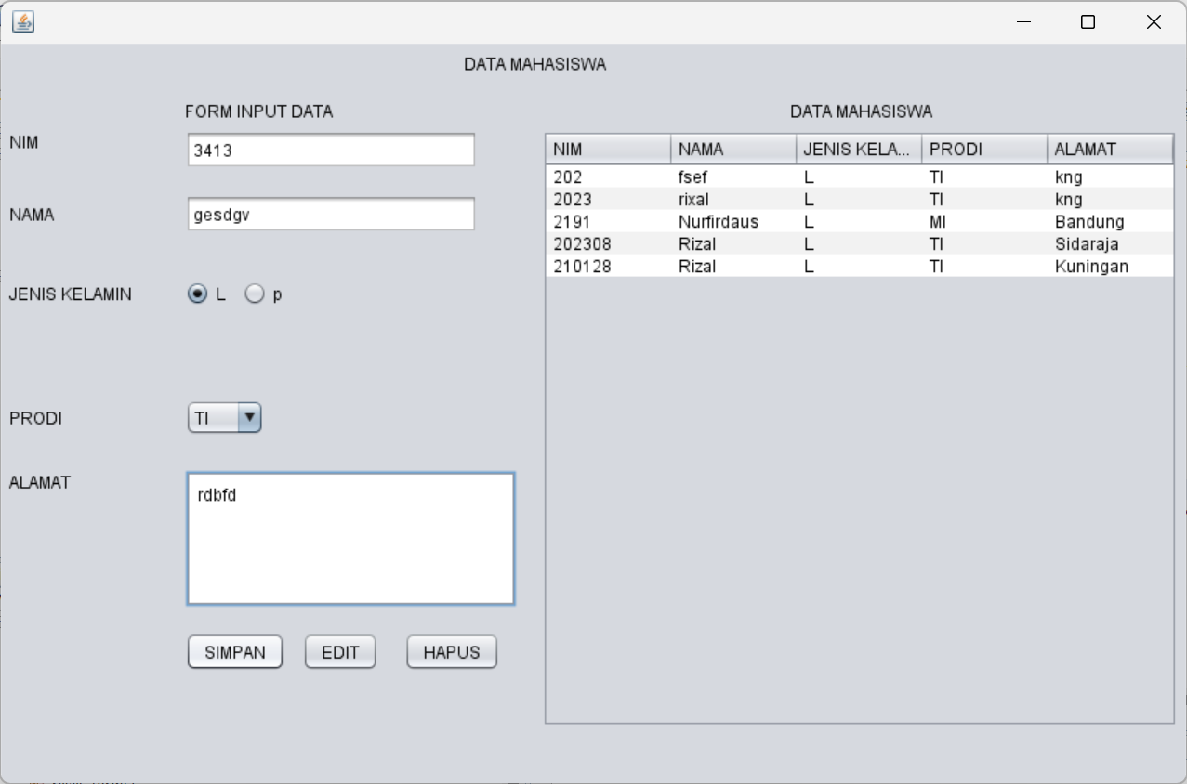
PostTest
1. lengkapi program, jika tombol simpan di klik akan menampilkan YesNoQuestion untuk penyimpanan data
2. jika tombol simpan di klik, Form Input Data akan kembali kosong seperti kondisi awal
3. jika tombol simpan diklik, data yang di input akan langsung tampil pada JTable.
/*
* To change this license header, choose License Headers in Project Properties.
* To change this template file, choose Tools | Templates
* and open the template in the editor.
*/

package bp1_m6_rizal;

import java.sql.ResultSet;
import java.sql.SQLException;
import java.sql.Statement;
import javax.swing.JOptionPane;
import javax.swing.table.DefaultTableModel;

/**
*
* @author Muhammad Rizal Nur F
*/
public class BP1_M6_P1_Rizal extends javax.swing.JFrame {
private Object JTable1;

Statement st;
ResultSet rs;
koneksi koneksi;

/**
* Creates new form BP1_M6_P1_Rizal
*/
public BP1_M6_P1_Rizal() {
koneksi = new koneksi();
initComponents();
load_data();
}
private void load_data() {
Object header[] = {"NIM", "NAMA", "JENIS KELAMIN", "PRODI", "ALAMAT"};
DefaultTableModel data = new DefaultTableModel(null, header);
jTable1.setModel(data);
String sql = "SELECT nim, nama, jk, prodi, alamat FROM tabel_mhs";
try {
st = koneksi.con.createStatement();
rs = st.executeQuery(sql);
while (rs.next()) {
String k1 = rs.getString("nim");
String k2 = rs.getString("nama");
String k3 = rs.getString("jk");
String k4 = rs.getString("prodi");
String k5 = rs.getString("alamat");

String k[] = {k1, k2, k3, k4, k5};
data.addRow(k);
}
} catch (Exception e) {
JOptionPane.showMessageDialog(null, e);
}
}

public void input_data() {
try {
String jk = jRadioButton1.isSelected() ? jRadioButton1.getText() : jRadioButton2.getText();

int confirm = JOptionPane.showConfirmDialog(null, "Apakah Anda yakin ingin menyimpan data?", "Konfirmasi", JOptionPane.YES_NO_OPTION);
if (confirm == JOptionPane.YES_OPTION) {
String sql = "INSERT INTO tabel_mhs (nim, nama, jk, prodi, alamat) VALUES ('"
+ jTextField1.getText() + "', '"
+ jTextField2.getText() + "', '"
+ jk + "', '"
+ jComboBox1.getSelectedItem().toString() + "', '"
+ jTextArea1.getText() + "')";
st = koneksi.con.createStatement();
st.execute(sql);
JOptionPane.showMessageDialog(null, "Data Mahasiswa Berhasil Disimpan");

load_data();

reset_form();
}
} catch (SQLException e) {
JOptionPane.showMessageDialog(null, "Error: " + e.getMessage());
}
}

private void reset_form() {
jTextField1.setText("");
jTextField2.setText("");
jRadioButton1.setSelected(false);
jRadioButton2.setSelected(false);
jComboBox1.setSelectedIndex(0);
jTextArea1.setText("");
}

/**
* This method is called from within the constructor to initialize the form.
* WARNING: Do NOT modify this code. The content of this method is always
* regenerated by the Form Editor.
*/
@SuppressWarnings("unchecked")
// <editor-fold defaultstate="collapsed" desc="Generated Code">
private void initComponents() {

jLabel1 = new javax.swing.JLabel();
jLabel2 = new javax.swing.JLabel();
jLabel3 = new javax.swing.JLabel();
jLabel4 = new javax.swing.JLabel();
jLabel5 = new javax.swing.JLabel();
jLabel6 = new javax.swing.JLabel();
jLabel7 = new javax.swing.JLabel();
jLabel8 = new javax.swing.JLabel();
jTextField1 = new javax.swing.JTextField();
jTextField2 = new javax.swing.JTextField();
jRadioButton1 = new javax.swing.JRadioButton();
jRadioButton2 = new javax.swing.JRadioButton();
jComboBox1 = new javax.swing.JComboBox();
jScrollPane1 = new javax.swing.JScrollPane();
jTextArea1 = new javax.swing.JTextArea();
ButtonSimpan = new javax.swing.JButton();
jButton2 = new javax.swing.JButton();
jButton3 = new javax.swing.JButton();
jScrollPane2 = new javax.swing.JScrollPane();
jTable1 = new javax.swing.JTable();

setDefaultCloseOperation(javax.swing.WindowConstants.EXIT_ON_CLOSE);

jLabel1.setText("DATA MAHASISWA");

jLabel2.setText("FORM INPUT DATA ");

jLabel3.setText("DATA MAHASISWA");

jLabel4.setText("NIM");

jLabel5.setText("NAMA");

jLabel6.setText("JENIS KELAMIN");

jLabel7.setText("PRODI");

jLabel8.setText("ALAMAT");

jTextField1.addActionListener(new java.awt.event.ActionListener() {
public void actionPerformed(java.awt.event.ActionEvent evt) {
jTextField1ActionPerformed(evt);
}
});

jRadioButton1.setText("L");

jRadioButton2.setText("p");

jComboBox1.setModel(new javax.swing.DefaultComboBoxModel(new String[] { "TI", "SI", "DKV", "MI", "TS" }));

jTextArea1.setColumns(20);
jTextArea1.setRows(5);
jScrollPane1.setViewportView(jTextArea1);

ButtonSimpan.setText("SIMPAN");
ButtonSimpan.addActionListener(new java.awt.event.ActionListener() {
public void actionPerformed(java.awt.event.ActionEvent evt) {
ButtonSimpanActionPerformed(evt);
}
});

jButton2.setText("EDIT");

jButton3.setText("HAPUS");

jTable1.setModel(new javax.swing.table.DefaultTableModel(
new Object [][] {
{null, null, null, null},
{null, null, null, null},
{null, null, null, null},
{null, null, null, null}
},
new String [] {
"Title 1", "Title 2", "Title 3", "Title 4"
}
));
jScrollPane2.setViewportView(jTable1);

javax.swing.GroupLayout layout = new javax.swing.GroupLayout(getContentPane());
getContentPane().setLayout(layout);
layout.setHorizontalGroup(
layout.createParallelGroup(javax.swing.GroupLayout.Alignment.LEADING)
.addGroup(layout.createSequentialGroup()
.addContainerGap()
.addGroup(layout.createParallelGroup(javax.swing.GroupLayout.Alignment.LEADING)
.addGroup(layout.createSequentialGroup()
.addGroup(layout.createParallelGroup(javax.swing.GroupLayout.Alignment.LEADING)
.addComponent(jLabel4)
.addComponent(jLabel5)
.addComponent(jLabel6)
.addComponent(jLabel7)
.addComponent(jLabel8))
.addGap(38, 38, 38)
.addGroup(layout.createParallelGroup(javax.swing.GroupLayout.Alignment.LEADING)
.addGroup(layout.createParallelGroup(javax.swing.GroupLayout.Alignment.LEADING, false)
.addComponent(jTextField1)
.addComponent(jTextField2, javax.swing.GroupLayout.DEFAULT_SIZE, 210, Short.MAX_VALUE))
.addComponent(jLabel2)
.addGroup(layout.createSequentialGroup()
.addComponent(jRadioButton1)
.addPreferredGap(javax.swing.LayoutStyle.ComponentPlacement.UNRELATED)
.addComponent(jRadioButton2))
.addComponent(jComboBox1, javax.swing.GroupLayout.PREFERRED_SIZE, javax.swing.GroupLayout.DEFAULT_SIZE, javax.swing.GroupLayout.PREFERRED_SIZE)
.addComponent(jScrollPane1, javax.swing.GroupLayout.PREFERRED_SIZE, javax.swing.GroupLayout.DEFAULT_SIZE, javax.swing.GroupLayout.PREFERRED_SIZE)
.addGroup(layout.createSequentialGroup()
.addComponent(ButtonSimpan)
.addPreferredGap(javax.swing.LayoutStyle.ComponentPlacement.UNRELATED)
.addComponent(jButton2)
.addGap(18, 18, 18)
.addComponent(jButton3)))
.addGroup(layout.createParallelGroup(javax.swing.GroupLayout.Alignment.LEADING)
.addGroup(layout.createSequentialGroup()
.addPreferredGap(javax.swing.LayoutStyle.ComponentPlacement.RELATED, javax.swing.GroupLayout.DEFAULT_SIZE, Short.MAX_VALUE)
.addComponent(jLabel3)
.addGap(188, 188, 188))
.addGroup(layout.createSequentialGroup()
.addGap(18, 18, 18)
.addComponent(jScrollPane2, javax.swing.GroupLayout.PREFERRED_SIZE, javax.swing.GroupLayout.DEFAULT_SIZE, javax.swing.GroupLayout.PREFERRED_SIZE)
.addContainerGap(javax.swing.GroupLayout.DEFAULT_SIZE, Short.MAX_VALUE))))
.addGroup(javax.swing.GroupLayout.Alignment.TRAILING, layout.createSequentialGroup()
.addGap(0, 0, Short.MAX_VALUE)
.addComponent(jLabel1)
.addGap(422, 422, 422))))
);
layout.setVerticalGroup(
layout.createParallelGroup(javax.swing.GroupLayout.Alignment.LEADING)
.addGroup(layout.createSequentialGroup()
.addContainerGap()
.addComponent(jLabel1)
.addGap(18, 18, 18)
.addGroup(layout.createParallelGroup(javax.swing.GroupLayout.Alignment.BASELINE)
.addComponent(jLabel2)
.addComponent(jLabel3))
.addPreferredGap(javax.swing.LayoutStyle.ComponentPlacement.RELATED)
.addGroup(layout.createParallelGroup(javax.swing.GroupLayout.Alignment.LEADING)
.addGroup(layout.createSequentialGroup()
.addGroup(layout.createParallelGroup(javax.swing.GroupLayout.Alignment.LEADING)
.addComponent(jLabel4)
.addComponent(jTextField1, javax.swing.GroupLayout.PREFERRED_SIZE, javax.swing.GroupLayout.DEFAULT_SIZE, javax.swing.GroupLayout.PREFERRED_SIZE))
.addGap(18, 18, 18)
.addGroup(layout.createParallelGroup(javax.swing.GroupLayout.Alignment.BASELINE)
.addComponent(jLabel5)
.addComponent(jTextField2, javax.swing.GroupLayout.PREFERRED_SIZE, javax.swing.GroupLayout.DEFAULT_SIZE, javax.swing.GroupLayout.PREFERRED_SIZE))
.addGap(34, 34, 34)
.addGroup(layout.createParallelGroup(javax.swing.GroupLayout.Alignment.BASELINE)
.addComponent(jLabel6)
.addComponent(jRadioButton1)
.addComponent(jRadioButton2))
.addGap(67, 67, 67)
.addGroup(layout.createParallelGroup(javax.swing.GroupLayout.Alignment.BASELINE)
.addComponent(jLabel7)
.addComponent(jComboBox1, javax.swing.GroupLayout.PREFERRED_SIZE, javax.swing.GroupLayout.DEFAULT_SIZE, javax.swing.GroupLayout.PREFERRED_SIZE))
.addGap(25, 25, 25)
.addGroup(layout.createParallelGroup(javax.swing.GroupLayout.Alignment.LEADING)
.addComponent(jLabel8)
.addComponent(jScrollPane1, javax.swing.GroupLayout.PREFERRED_SIZE, javax.swing.GroupLayout.DEFAULT_SIZE, javax.swing.GroupLayout.PREFERRED_SIZE))
.addGap(18, 18, 18)
.addGroup(layout.createParallelGroup(javax.swing.GroupLayout.Alignment.BASELINE)
.addComponent(ButtonSimpan)
.addComponent(jButton2)
.addComponent(jButton3)))
.addComponent(jScrollPane2, javax.swing.GroupLayout.PREFERRED_SIZE, javax.swing.GroupLayout.DEFAULT_SIZE, javax.swing.GroupLayout.PREFERRED_SIZE))
.addContainerGap(41, Short.MAX_VALUE))
);

pack();
}// </editor-fold>

private void jTextField1ActionPerformed(java.awt.event.ActionEvent evt) {
// TODO add your handling code here:
}

private void ButtonSimpanActionPerformed(java.awt.event.ActionEvent evt) {
// TODO add your handling code here:
input_data();
}

/**
* @param args the command line arguments
*/
public static void main(String args[]) {
/* Set the Nimbus look and feel */
//<editor-fold defaultstate="collapsed" desc=" Look and feel setting code (optional) ">
/* If Nimbus (introduced in Java SE 6) is not available, stay with the default look and feel.
* For details see http://download.oracle.com/javase/tutorial/uiswing/lookandfeel/plaf.html
*/
try {
for (javax.swing.UIManager.LookAndFeelInfo info : javax.swing.UIManager.getInstalledLookAndFeels()) {
if ("Nimbus".equals(info.getName())) {
javax.swing.UIManager.setLookAndFeel(info.getClassName());
break;
}
}
} catch (ClassNotFoundException ex) {
java.util.logging.Logger.getLogger(BP1_M6_P1_Rizal.class.getName()).log(java.util.logging.Level.SEVERE, null, ex);
} catch (InstantiationException ex) {
java.util.logging.Logger.getLogger(BP1_M6_P1_Rizal.class.getName()).log(java.util.logging.Level.SEVERE, null, ex);
} catch (IllegalAccessException ex) {
java.util.logging.Logger.getLogger(BP1_M6_P1_Rizal.class.getName()).log(java.util.logging.Level.SEVERE, null, ex);
} catch (javax.swing.UnsupportedLookAndFeelException ex) {
java.util.logging.Logger.getLogger(BP1_M6_P1_Rizal.class.getName()).log(java.util.logging.Level.SEVERE, null, ex);
}
//</editor-fold>

/* Create and display the form */
java.awt.EventQueue.invokeLater(new Runnable() {
public void run() {
new BP1_M6_P1_Rizal().setVisible(true);
}
});
}

// Variables declaration - do not modify
private javax.swing.JButton ButtonSimpan;
private javax.swing.JButton jButton2;
private javax.swing.JButton jButton3;
private javax.swing.JComboBox jComboBox1;
private javax.swing.JLabel jLabel1;
private javax.swing.JLabel jLabel2;
private javax.swing.JLabel jLabel3;
private javax.swing.JLabel jLabel4;
private javax.swing.JLabel jLabel5;
private javax.swing.JLabel jLabel6;
private javax.swing.JLabel jLabel7;
private javax.swing.JLabel jLabel8;
private javax.swing.JRadioButton jRadioButton1;
private javax.swing.JRadioButton jRadioButton2;
private javax.swing.JScrollPane jScrollPane1;
private javax.swing.JScrollPane jScrollPane2;
private javax.swing.JTable jTable1;
private javax.swing.JTextArea jTextArea1;
private javax.swing.JTextField jTextField1;
private javax.swing.JTextField jTextField2;
// End of variables declaration
}
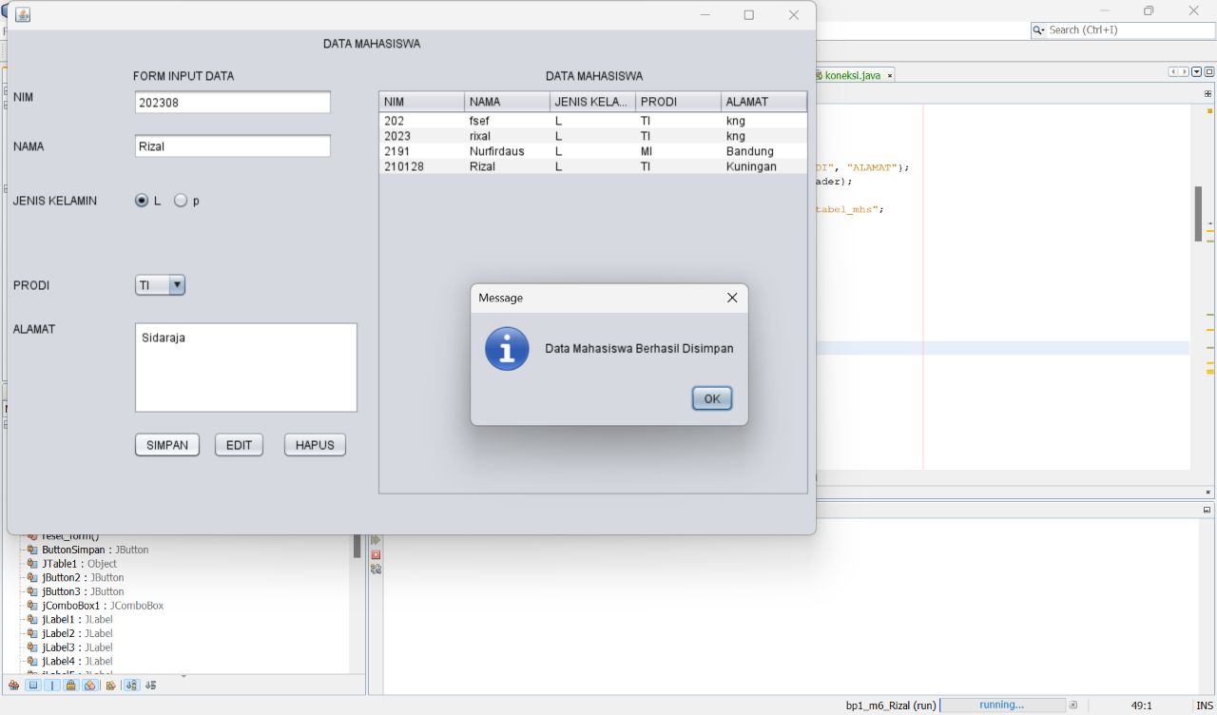
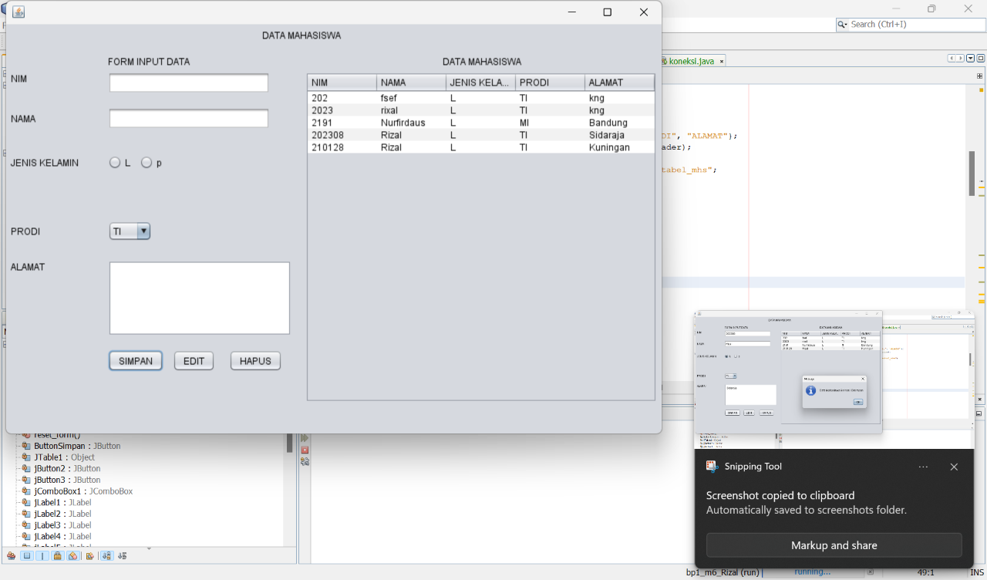
Tugas
- Lengkapi program, jika tombol simpan di klik tetapi ada data yang belum terisi maka akan menampilkan pesan “Data Harus Diisi !”
- Lengkapi Button Edit dan Hapus
/*
* To change this license header, choose License Headers in Project Properties.
* To change this template file, choose Tools | Templates
* and open the template in the editor.
*/

package bp1_m6_rizal;

import java.sql.ResultSet;
import java.sql.SQLException;
import java.sql.Statement;
import javax.swing.JOptionPane;
import javax.swing.table.DefaultTableModel;

/**
*
* @author Muhammad Rizal Nur F
*/
public class BP1_M6_P1_Rizal extends javax.swing.JFrame {
private Object JTable1;

Statement st;
ResultSet rs;
koneksi koneksi;

/**
* Creates new form BP1_M6_P1_Rizal
*/
public BP1_M6_P1_Rizal() {
koneksi = new koneksi();
initComponents();
load_data();
}
private void load_data() {
Object header[] = {"NIM", "NAMA", "JENIS KELAMIN", "PRODI", "ALAMAT"};
DefaultTableModel data = new DefaultTableModel(null, header);
jTable1.setModel(data);
String sql = "SELECT nim, nama, jk, prodi, alamat FROM tabel_mhs";
try {
st = koneksi.con.createStatement();
rs = st.executeQuery(sql);
while (rs.next()) {
String k1 = rs.getString("nim");
String k2 = rs.getString("nama");
String k3 = rs.getString("jk");
String k4 = rs.getString("prodi");
String k5 = rs.getString("alamat");

String k[] = {k1, k2, k3, k4, k5};
data.addRow(k);
}
} catch (Exception e) {
JOptionPane.showMessageDialog(null, e);
}
}

public void input_data() {
try {
// Validasi input: Pastikan semua data terisi
if (jTextField1.getText().isEmpty() ||
jTextField2.getText().isEmpty() ||
(!jRadioButton1.isSelected() && !jRadioButton2.isSelected()) ||
jTextArea1.getText().isEmpty()) {
JOptionPane.showMessageDialog(null, "Data Harus Diisi!", "Peringatan", JOptionPane.WARNING_MESSAGE);
return;
}

// Ambil nilai jenis kelamin
String jk = jRadioButton1.isSelected() ? jRadioButton1.getText() : jRadioButton2.getText();

// Konfirmasi penyimpanan data
int confirm = JOptionPane.showConfirmDialog(null, "Apakah Anda yakin ingin menyimpan data?", "Konfirmasi", JOptionPane.YES_NO_OPTION);
if (confirm == JOptionPane.YES_OPTION) {
String sql = "INSERT INTO tabel_mhs (nim, nama, jk, prodi, alamat) VALUES ('"
+ jTextField1.getText() + "', '"
+ jTextField2.getText() + "', '"
+ jk + "', '"
+ jComboBox1.getSelectedItem().toString() + "', '"
+ jTextArea1.getText() + "')";
st = koneksi.con.createStatement();
st.execute(sql);
JOptionPane.showMessageDialog(null, "Data Mahasiswa Berhasil Disimpan");

// Muat ulang data di tabel dan reset form
load_data();
reset_form();
}
} catch (SQLException e) {
JOptionPane.showMessageDialog(null, "Error: " + e.getMessage());
}
}

private void reset_form() {
jTextField1.setText("");
jTextField2.setText("");
jRadioButton1.setSelected(false);
jRadioButton2.setSelected(false);
jComboBox1.setSelectedIndex(0);
jTextArea1.setText("");
}

/**
* This method is called from within the constructor to initialize the form.
* WARNING: Do NOT modify this code. The content of this method is always
* regenerated by the Form Editor.
*/
@SuppressWarnings("unchecked")
// <editor-fold defaultstate="collapsed" desc="Generated Code">
private void initComponents() {

jLabel1 = new javax.swing.JLabel();
jLabel2 = new javax.swing.JLabel();
jLabel3 = new javax.swing.JLabel();
jLabel4 = new javax.swing.JLabel();
jLabel5 = new javax.swing.JLabel();
jLabel6 = new javax.swing.JLabel();
jLabel7 = new javax.swing.JLabel();
jLabel8 = new javax.swing.JLabel();
jTextField1 = new javax.swing.JTextField();
jTextField2 = new javax.swing.JTextField();
jRadioButton1 = new javax.swing.JRadioButton();
jRadioButton2 = new javax.swing.JRadioButton();
jComboBox1 = new javax.swing.JComboBox();
jScrollPane1 = new javax.swing.JScrollPane();
jTextArea1 = new javax.swing.JTextArea();
ButtonSimpan = new javax.swing.JButton();
jButton2 = new javax.swing.JButton();
jButton3 = new javax.swing.JButton();
jScrollPane2 = new javax.swing.JScrollPane();
jTable1 = new javax.swing.JTable();

setDefaultCloseOperation(javax.swing.WindowConstants.EXIT_ON_CLOSE);

jLabel1.setText("DATA MAHASISWA");

jLabel2.setText("FORM INPUT DATA ");

jLabel3.setText("DATA MAHASISWA");

jLabel4.setText("NIM");

jLabel5.setText("NAMA");

jLabel6.setText("JENIS KELAMIN");

jLabel7.setText("PRODI");

jLabel8.setText("ALAMAT");

jTextField1.addActionListener(new java.awt.event.ActionListener() {
public void actionPerformed(java.awt.event.ActionEvent evt) {
jTextField1ActionPerformed(evt);
}
});

jRadioButton1.setText("L");

jRadioButton2.setText("p");

jComboBox1.setModel(new javax.swing.DefaultComboBoxModel(new String[] { "TI", "SI", "DKV", "MI", "TS" }));

jTextArea1.setColumns(20);
jTextArea1.setRows(5);
jScrollPane1.setViewportView(jTextArea1);

ButtonSimpan.setText("SIMPAN");
ButtonSimpan.addActionListener(new java.awt.event.ActionListener() {
public void actionPerformed(java.awt.event.ActionEvent evt) {
ButtonSimpanActionPerformed(evt);
}
});

jButton2.setText("EDIT");

jButton3.setText("HAPUS");

jTable1.setModel(new javax.swing.table.DefaultTableModel(
new Object [][] {
{null, null, null, null},
{null, null, null, null},
{null, null, null, null},
{null, null, null, null}
},
new String [] {
"Title 1", "Title 2", "Title 3", "Title 4"
}
));
jScrollPane2.setViewportView(jTable1);

javax.swing.GroupLayout layout = new javax.swing.GroupLayout(getContentPane());
getContentPane().setLayout(layout);
layout.setHorizontalGroup(
layout.createParallelGroup(javax.swing.GroupLayout.Alignment.LEADING)
.addGroup(layout.createSequentialGroup()
.addContainerGap()
.addGroup(layout.createParallelGroup(javax.swing.GroupLayout.Alignment.LEADING)
.addGroup(layout.createSequentialGroup()
.addGroup(layout.createParallelGroup(javax.swing.GroupLayout.Alignment.LEADING)
.addComponent(jLabel4)
.addComponent(jLabel5)
.addComponent(jLabel6)
.addComponent(jLabel7)
.addComponent(jLabel8))
.addGap(38, 38, 38)
.addGroup(layout.createParallelGroup(javax.swing.GroupLayout.Alignment.LEADING)
.addGroup(layout.createParallelGroup(javax.swing.GroupLayout.Alignment.LEADING, false)
.addComponent(jTextField1)
.addComponent(jTextField2, javax.swing.GroupLayout.DEFAULT_SIZE, 210, Short.MAX_VALUE))
.addComponent(jLabel2)
.addGroup(layout.createSequentialGroup()
.addComponent(jRadioButton1)
.addPreferredGap(javax.swing.LayoutStyle.ComponentPlacement.UNRELATED)
.addComponent(jRadioButton2))
.addComponent(jComboBox1, javax.swing.GroupLayout.PREFERRED_SIZE, javax.swing.GroupLayout.DEFAULT_SIZE, javax.swing.GroupLayout.PREFERRED_SIZE)
.addComponent(jScrollPane1, javax.swing.GroupLayout.PREFERRED_SIZE, javax.swing.GroupLayout.DEFAULT_SIZE, javax.swing.GroupLayout.PREFERRED_SIZE)
.addGroup(layout.createSequentialGroup()
.addComponent(ButtonSimpan)
.addPreferredGap(javax.swing.LayoutStyle.ComponentPlacement.UNRELATED)
.addComponent(jButton2)
.addGap(18, 18, 18)
.addComponent(jButton3)))
.addGroup(layout.createParallelGroup(javax.swing.GroupLayout.Alignment.LEADING)
.addGroup(layout.createSequentialGroup()
.addPreferredGap(javax.swing.LayoutStyle.ComponentPlacement.RELATED, javax.swing.GroupLayout.DEFAULT_SIZE, Short.MAX_VALUE)
.addComponent(jLabel3)
.addGap(188, 188, 188))
.addGroup(layout.createSequentialGroup()
.addGap(18, 18, 18)
.addComponent(jScrollPane2, javax.swing.GroupLayout.PREFERRED_SIZE, javax.swing.GroupLayout.DEFAULT_SIZE, javax.swing.GroupLayout.PREFERRED_SIZE)
.addContainerGap(javax.swing.GroupLayout.DEFAULT_SIZE, Short.MAX_VALUE))))
.addGroup(javax.swing.GroupLayout.Alignment.TRAILING, layout.createSequentialGroup()
.addGap(0, 0, Short.MAX_VALUE)
.addComponent(jLabel1)
.addGap(422, 422, 422))))
);
layout.setVerticalGroup(
layout.createParallelGroup(javax.swing.GroupLayout.Alignment.LEADING)
.addGroup(layout.createSequentialGroup()
.addContainerGap()
.addComponent(jLabel1)
.addGap(18, 18, 18)
.addGroup(layout.createParallelGroup(javax.swing.GroupLayout.Alignment.BASELINE)
.addComponent(jLabel2)
.addComponent(jLabel3))
.addPreferredGap(javax.swing.LayoutStyle.ComponentPlacement.RELATED)
.addGroup(layout.createParallelGroup(javax.swing.GroupLayout.Alignment.LEADING)
.addGroup(layout.createSequentialGroup()
.addGroup(layout.createParallelGroup(javax.swing.GroupLayout.Alignment.LEADING)
.addComponent(jLabel4)
.addComponent(jTextField1, javax.swing.GroupLayout.PREFERRED_SIZE, javax.swing.GroupLayout.DEFAULT_SIZE, javax.swing.GroupLayout.PREFERRED_SIZE))
.addGap(18, 18, 18)
.addGroup(layout.createParallelGroup(javax.swing.GroupLayout.Alignment.BASELINE)
.addComponent(jLabel5)
.addComponent(jTextField2, javax.swing.GroupLayout.PREFERRED_SIZE, javax.swing.GroupLayout.DEFAULT_SIZE, javax.swing.GroupLayout.PREFERRED_SIZE))
.addGap(34, 34, 34)
.addGroup(layout.createParallelGroup(javax.swing.GroupLayout.Alignment.BASELINE)
.addComponent(jLabel6)
.addComponent(jRadioButton1)
.addComponent(jRadioButton2))
.addGap(67, 67, 67)
.addGroup(layout.createParallelGroup(javax.swing.GroupLayout.Alignment.BASELINE)
.addComponent(jLabel7)
.addComponent(jComboBox1, javax.swing.GroupLayout.PREFERRED_SIZE, javax.swing.GroupLayout.DEFAULT_SIZE, javax.swing.GroupLayout.PREFERRED_SIZE))
.addGap(25, 25, 25)
.addGroup(layout.createParallelGroup(javax.swing.GroupLayout.Alignment.LEADING)
.addComponent(jLabel8)
.addComponent(jScrollPane1, javax.swing.GroupLayout.PREFERRED_SIZE, javax.swing.GroupLayout.DEFAULT_SIZE, javax.swing.GroupLayout.PREFERRED_SIZE))
.addGap(18, 18, 18)
.addGroup(layout.createParallelGroup(javax.swing.GroupLayout.Alignment.BASELINE)
.addComponent(ButtonSimpan)
.addComponent(jButton2)
.addComponent(jButton3)))
.addComponent(jScrollPane2, javax.swing.GroupLayout.PREFERRED_SIZE, javax.swing.GroupLayout.DEFAULT_SIZE, javax.swing.GroupLayout.PREFERRED_SIZE))
.addContainerGap(41, Short.MAX_VALUE))
);

pack();
}// </editor-fold>

private void jTextField1ActionPerformed(java.awt.event.ActionEvent evt) {
// TODO add your handling code here:
}

private void ButtonSimpanActionPerformed(java.awt.event.ActionEvent evt) {
// TODO add your handling code here:
input_data();
}

/**
* @param args the command line arguments
*/
public static void main(String args[]) {
/* Set the Nimbus look and feel */
//<editor-fold defaultstate="collapsed" desc=" Look and feel setting code (optional) ">
/* If Nimbus (introduced in Java SE 6) is not available, stay with the default look and feel.
* For details see http://download.oracle.com/javase/tutorial/uiswing/lookandfeel/plaf.html
*/
try {
for (javax.swing.UIManager.LookAndFeelInfo info : javax.swing.UIManager.getInstalledLookAndFeels()) {
if ("Nimbus".equals(info.getName())) {
javax.swing.UIManager.setLookAndFeel(info.getClassName());
break;
}
}
} catch (ClassNotFoundException ex) {
java.util.logging.Logger.getLogger(BP1_M6_P1_Rizal.class.getName()).log(java.util.logging.Level.SEVERE, null, ex);
} catch (InstantiationException ex) {
java.util.logging.Logger.getLogger(BP1_M6_P1_Rizal.class.getName()).log(java.util.logging.Level.SEVERE, null, ex);
} catch (IllegalAccessException ex) {
java.util.logging.Logger.getLogger(BP1_M6_P1_Rizal.class.getName()).log(java.util.logging.Level.SEVERE, null, ex);
} catch (javax.swing.UnsupportedLookAndFeelException ex) {
java.util.logging.Logger.getLogger(BP1_M6_P1_Rizal.class.getName()).log(java.util.logging.Level.SEVERE, null, ex);
}
//</editor-fold>

/* Create and display the form */
java.awt.EventQueue.invokeLater(new Runnable() {
public void run() {
new BP1_M6_P1_Rizal().setVisible(true);
}
});
}

// Variables declaration - do not modify
private javax.swing.JButton ButtonSimpan;
private javax.swing.JButton jButton2;
private javax.swing.JButton jButton3;
private javax.swing.JComboBox jComboBox1;
private javax.swing.JLabel jLabel1;
private javax.swing.JLabel jLabel2;
private javax.swing.JLabel jLabel3;
private javax.swing.JLabel jLabel4;
private javax.swing.JLabel jLabel5;
private javax.swing.JLabel jLabel6;
private javax.swing.JLabel jLabel7;
private javax.swing.JLabel jLabel8;
private javax.swing.JRadioButton jRadioButton1;
private javax.swing.JRadioButton jRadioButton2;
private javax.swing.JScrollPane jScrollPane1;
private javax.swing.JScrollPane jScrollPane2;
private javax.swing.JTable jTable1;
private javax.swing.JTextArea jTextArea1;
private javax.swing.JTextField jTextField1;
private javax.swing.JTextField jTextField2;
// End of variables declaration
}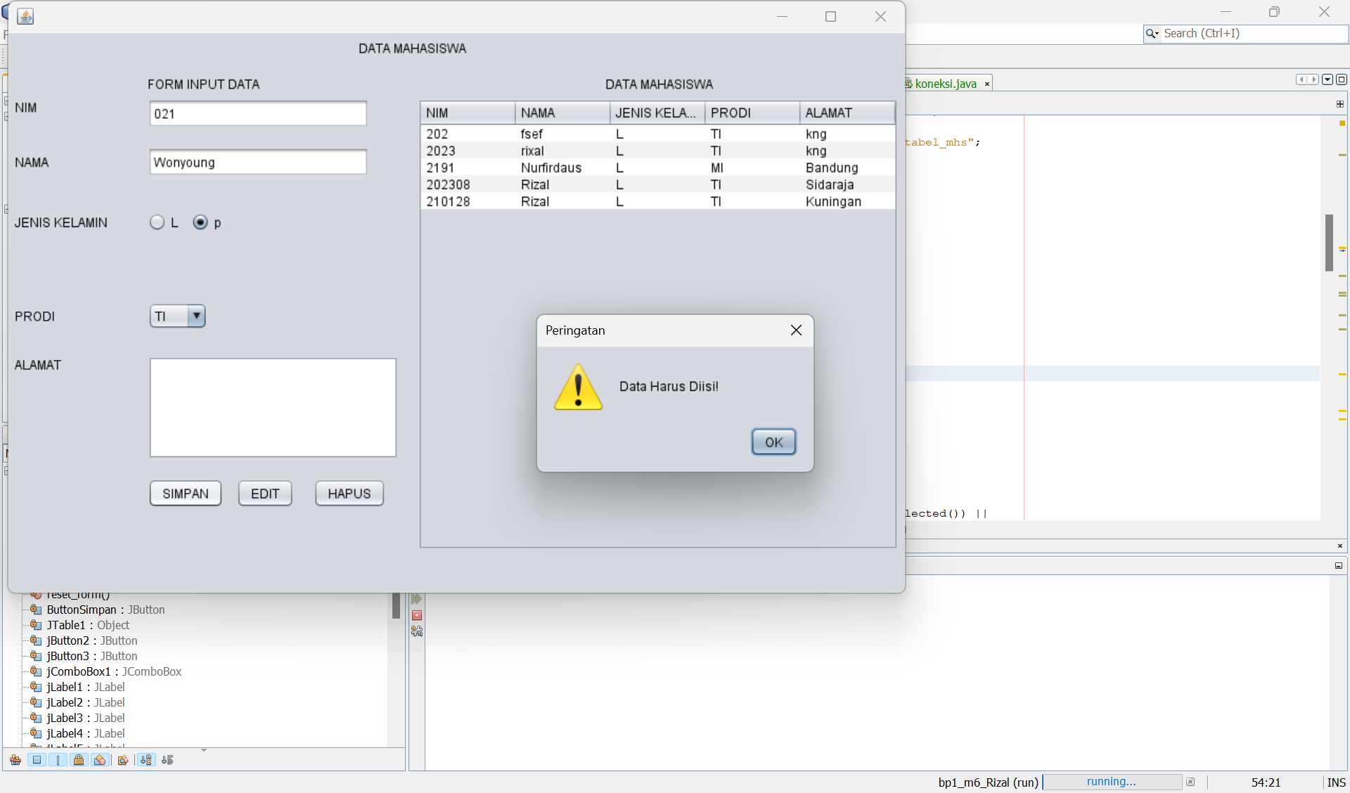

Modul 8
PreTest
- Tuliskan sql query untuk input, simpan, update, dan delete!
CREATE TABLE mahasiswa (
id INT AUTO_INCREMENT PRIMARY KEY,
nama VARCHAR(100),
umur INT,
nilai VARCHAR(10)
);

INSERT INTO students (name, umur, nilai)
VALUES ('Rizal', 19, 'A');

SELECT * FROM mahasiswa;

UPDATE mahasiswa
SET nilai = 'B'
WHERE id = 1;

DELETE FROM mahasiswa
WHERE id = 1;
Praktikum

/*
* To change this license header, choose License Headers in Project Properties.
* To change this template file, choose Tools | Templates
* and open the template in the editor.
*/

package bp1_m6_rizal;

import java.sql.ResultSet;
import java.sql.SQLException;
import java.sql.Statement;
import javax.swing.JOptionPane;
import javax.swing.table.DefaultTableModel;

/**
*
* @author Muhammad Rizal Nur F
*/
public class BP1_M6_P1_Rizal extends javax.swing.JFrame {
private Object JTable1;

Statement st;
ResultSet rs;
koneksi koneksi;

/**
* Creates new form BP1_M6_P1_Rizal
*/
public BP1_M6_P1_Rizal() {
koneksi = new koneksi();
initComponents();
load_data();
}
private void load_data() {
Object header[] = {"NIM", "NAMA", "JENIS KELAMIN", "PRODI", "ALAMAT"};
DefaultTableModel data = new DefaultTableModel(null, header);
jTable1.setModel(data);
String sql = "SELECT nim, nama, jk, prodi, alamat FROM tabel_mhs";
try {
st = koneksi.con.createStatement();
rs = st.executeQuery(sql);
while (rs.next()) {
String k1 = rs.getString("nim");
String k2 = rs.getString("nama");
String k3 = rs.getString("jk");
String k4 = rs.getString("prodi");
String k5 = rs.getString("alamat");

String k[] = {k1, k2, k3, k4, k5};
data.addRow(k);
}
} catch (Exception e) {
JOptionPane.showMessageDialog(null, e);
}
}

public void input_data() {
try {
// Validasi input: Pastikan semua data terisi
if (jTextField1.getText().isEmpty() ||
jTextField2.getText().isEmpty() ||
(!jRadioButton1.isSelected() && !jRadioButton2.isSelected()) ||
jTextArea1.getText().isEmpty()) {
JOptionPane.showMessageDialog(null, "Data Harus Diisi!", "Peringatan", JOptionPane.WARNING_MESSAGE);
return;
}

// Ambil nilai jenis kelamin
String jk = jRadioButton1.isSelected() ? jRadioButton1.getText() : jRadioButton2.getText();

// Konfirmasi penyimpanan data
int confirm = JOptionPane.showConfirmDialog(null, "Apakah Anda yakin ingin menyimpan data?", "Konfirmasi", JOptionPane.YES_NO_OPTION);
if (confirm == JOptionPane.YES_OPTION) {
String sql = "INSERT INTO tabel_mhs (nim, nama, jk, prodi, alamat) VALUES ('"
+ jTextField1.getText() + "', '"
+ jTextField2.getText() + "', '"
+ jk + "', '"
+ jComboBox1.getSelectedItem().toString() + "', '"
+ jTextArea1.getText() + "')";
st = koneksi.con.createStatement();
st.execute(sql);
JOptionPane.showMessageDialog(null, "Data Mahasiswa Berhasil Disimpan");

// Muat ulang data di tabel dan reset form
load_data();
reset_form();
}
} catch (SQLException e) {
JOptionPane.showMessageDialog(null, "Error: " + e.getMessage());
}
}

private void reset_form() {
jTextField1.setText("");
jTextField2.setText("");
jRadioButton1.setSelected(false);
jRadioButton2.setSelected(false);
jComboBox1.setSelectedIndex(0);
jTextArea1.setText("");
}

/**
* This method is called from within the constructor to initialize the form.
* WARNING: Do NOT modify this code. The content of this method is always
* regenerated by the Form Editor.
*/
@SuppressWarnings("unchecked")
// <editor-fold defaultstate="collapsed" desc="Generated Code">
private void initComponents() {

jLabel1 = new javax.swing.JLabel();
jLabel2 = new javax.swing.JLabel();
jLabel3 = new javax.swing.JLabel();
jLabel4 = new javax.swing.JLabel();
jLabel5 = new javax.swing.JLabel();
jLabel6 = new javax.swing.JLabel();
jLabel7 = new javax.swing.JLabel();
jLabel8 = new javax.swing.JLabel();
jTextField1 = new javax.swing.JTextField();
jTextField2 = new javax.swing.JTextField();
jRadioButton1 = new javax.swing.JRadioButton();
jRadioButton2 = new javax.swing.JRadioButton();
jComboBox1 = new javax.swing.JComboBox();
jScrollPane1 = new javax.swing.JScrollPane();
jTextArea1 = new javax.swing.JTextArea();
ButtonSimpan = new javax.swing.JButton();
jButton2 = new javax.swing.JButton();
jButton3 = new javax.swing.JButton();
jScrollPane2 = new javax.swing.JScrollPane();
jTable1 = new javax.swing.JTable();

setDefaultCloseOperation(javax.swing.WindowConstants.EXIT_ON_CLOSE);

jLabel1.setText("DATA MAHASISWA");

jLabel2.setText("FORM INPUT DATA ");

jLabel3.setText("DATA MAHASISWA");

jLabel4.setText("NIM");

jLabel5.setText("NAMA");

jLabel6.setText("JENIS KELAMIN");

jLabel7.setText("PRODI");

jLabel8.setText("ALAMAT");

jTextField1.addActionListener(new java.awt.event.ActionListener() {
public void actionPerformed(java.awt.event.ActionEvent evt) {
jTextField1ActionPerformed(evt);
}
});

jRadioButton1.setText("L");

jRadioButton2.setText("p");

jComboBox1.setModel(new javax.swing.DefaultComboBoxModel(new String[] { "TI", "SI", "DKV", "MI", "TS" }));

jTextArea1.setColumns(20);
jTextArea1.setRows(5);
jScrollPane1.setViewportView(jTextArea1);

ButtonSimpan.setText("SIMPAN");
ButtonSimpan.addActionListener(new java.awt.event.ActionListener() {
public void actionPerformed(java.awt.event.ActionEvent evt) {
ButtonSimpanActionPerformed(evt);
}
});

jButton2.setText("EDIT");
jButton2.addMouseListener(new java.awt.event.MouseAdapter() {
public void mouseClicked(java.awt.event.MouseEvent evt) {
jButton2MouseClicked(evt);
}
});

jButton3.setText("HAPUS");
jButton3.addMouseListener(new java.awt.event.MouseAdapter() {
public void mouseClicked(java.awt.event.MouseEvent evt) {
jButton3MouseClicked(evt);
}
});

jTable1.setModel(new javax.swing.table.DefaultTableModel(
new Object [][] {
{null, null, null, null},
{null, null, null, null},
{null, null, null, null},
{null, null, null, null}
},
new String [] {
"Title 1", "Title 2", "Title 3", "Title 4"
}
));
jScrollPane2.setViewportView(jTable1);

javax.swing.GroupLayout layout = new javax.swing.GroupLayout(getContentPane());
getContentPane().setLayout(layout);
layout.setHorizontalGroup(
layout.createParallelGroup(javax.swing.GroupLayout.Alignment.LEADING)
.addGroup(layout.createSequentialGroup()
.addContainerGap()
.addGroup(layout.createParallelGroup(javax.swing.GroupLayout.Alignment.LEADING)
.addGroup(layout.createSequentialGroup()
.addGroup(layout.createParallelGroup(javax.swing.GroupLayout.Alignment.LEADING)
.addComponent(jLabel4)
.addComponent(jLabel5)
.addComponent(jLabel6)
.addComponent(jLabel7)
.addComponent(jLabel8))
.addGap(38, 38, 38)
.addGroup(layout.createParallelGroup(javax.swing.GroupLayout.Alignment.LEADING)
.addGroup(layout.createParallelGroup(javax.swing.GroupLayout.Alignment.LEADING, false)
.addComponent(jTextField1)
.addComponent(jTextField2, javax.swing.GroupLayout.DEFAULT_SIZE, 210, Short.MAX_VALUE))
.addComponent(jLabel2)
.addGroup(layout.createSequentialGroup()
.addComponent(jRadioButton1)
.addPreferredGap(javax.swing.LayoutStyle.ComponentPlacement.UNRELATED)
.addComponent(jRadioButton2))
.addComponent(jComboBox1, javax.swing.GroupLayout.PREFERRED_SIZE, javax.swing.GroupLayout.DEFAULT_SIZE, javax.swing.GroupLayout.PREFERRED_SIZE)
.addComponent(jScrollPane1, javax.swing.GroupLayout.PREFERRED_SIZE, javax.swing.GroupLayout.DEFAULT_SIZE, javax.swing.GroupLayout.PREFERRED_SIZE)
.addGroup(layout.createSequentialGroup()
.addComponent(ButtonSimpan)
.addPreferredGap(javax.swing.LayoutStyle.ComponentPlacement.UNRELATED)
.addComponent(jButton2)
.addGap(18, 18, 18)
.addComponent(jButton3)))
.addGroup(layout.createParallelGroup(javax.swing.GroupLayout.Alignment.LEADING)
.addGroup(layout.createSequentialGroup()
.addPreferredGap(javax.swing.LayoutStyle.ComponentPlacement.RELATED, javax.swing.GroupLayout.DEFAULT_SIZE, Short.MAX_VALUE)
.addComponent(jLabel3)
.addGap(188, 188, 188))
.addGroup(layout.createSequentialGroup()
.addGap(18, 18, 18)
.addComponent(jScrollPane2, javax.swing.GroupLayout.PREFERRED_SIZE, javax.swing.GroupLayout.DEFAULT_SIZE, javax.swing.GroupLayout.PREFERRED_SIZE)
.addContainerGap(javax.swing.GroupLayout.DEFAULT_SIZE, Short.MAX_VALUE))))
.addGroup(javax.swing.GroupLayout.Alignment.TRAILING, layout.createSequentialGroup()
.addGap(0, 0, Short.MAX_VALUE)
.addComponent(jLabel1)
.addGap(422, 422, 422))))
);
layout.setVerticalGroup(
layout.createParallelGroup(javax.swing.GroupLayout.Alignment.LEADING)
.addGroup(layout.createSequentialGroup()
.addContainerGap()
.addComponent(jLabel1)
.addGap(18, 18, 18)
.addGroup(layout.createParallelGroup(javax.swing.GroupLayout.Alignment.BASELINE)
.addComponent(jLabel2)
.addComponent(jLabel3))
.addPreferredGap(javax.swing.LayoutStyle.ComponentPlacement.RELATED)
.addGroup(layout.createParallelGroup(javax.swing.GroupLayout.Alignment.LEADING)
.addGroup(layout.createSequentialGroup()
.addGroup(layout.createParallelGroup(javax.swing.GroupLayout.Alignment.LEADING)
.addComponent(jLabel4)
.addComponent(jTextField1, javax.swing.GroupLayout.PREFERRED_SIZE, javax.swing.GroupLayout.DEFAULT_SIZE, javax.swing.GroupLayout.PREFERRED_SIZE))
.addGap(18, 18, 18)
.addGroup(layout.createParallelGroup(javax.swing.GroupLayout.Alignment.BASELINE)
.addComponent(jLabel5)
.addComponent(jTextField2, javax.swing.GroupLayout.PREFERRED_SIZE, javax.swing.GroupLayout.DEFAULT_SIZE, javax.swing.GroupLayout.PREFERRED_SIZE))
.addGap(34, 34, 34)
.addGroup(layout.createParallelGroup(javax.swing.GroupLayout.Alignment.BASELINE)
.addComponent(jLabel6)
.addComponent(jRadioButton1)
.addComponent(jRadioButton2))
.addGap(67, 67, 67)
.addGroup(layout.createParallelGroup(javax.swing.GroupLayout.Alignment.BASELINE)
.addComponent(jLabel7)
.addComponent(jComboBox1, javax.swing.GroupLayout.PREFERRED_SIZE, javax.swing.GroupLayout.DEFAULT_SIZE, javax.swing.GroupLayout.PREFERRED_SIZE))
.addGap(25, 25, 25)
.addGroup(layout.createParallelGroup(javax.swing.GroupLayout.Alignment.LEADING)
.addComponent(jLabel8)
.addComponent(jScrollPane1, javax.swing.GroupLayout.PREFERRED_SIZE, javax.swing.GroupLayout.DEFAULT_SIZE, javax.swing.GroupLayout.PREFERRED_SIZE))
.addGap(18, 18, 18)
.addGroup(layout.createParallelGroup(javax.swing.GroupLayout.Alignment.BASELINE)
.addComponent(ButtonSimpan)
.addComponent(jButton2)
.addComponent(jButton3)))
.addComponent(jScrollPane2, javax.swing.GroupLayout.PREFERRED_SIZE, javax.swing.GroupLayout.DEFAULT_SIZE, javax.swing.GroupLayout.PREFERRED_SIZE))
.addContainerGap(41, Short.MAX_VALUE))
);

pack();
}// </editor-fold>

private void jTextField1ActionPerformed(java.awt.event.ActionEvent evt) {
// TODO add your handling code here:
}

private void ButtonSimpanActionPerformed(java.awt.event.ActionEvent evt) {
// TODO add your handling code here:
input_data();
}

private void jButton2MouseClicked(java.awt.event.MouseEvent evt) {
// TODO add your handling code here:
// Button Edit
try()
{
String jk="";
if(jRadioButton1.isSelected())
{jk=jRadioButton1.getText();}
else
{jk=jRadioButton2.getText();}

String sql_edit = "UPDATE mhs SET nim = '"+jTextField1.getText()
+"','"+jTextField2.getText()
+"','"+jk
+"','"+jComboBox1.getText()
+"','"+jTextArea1.getText()
+"'WHERE nim='"+jTextField1.getText()
+"'";

st.executeUpdate(sql_edit);
JOptionPane.showMessageDialog(null, "Data Mahasiswa Berhenti Di Update");
}
catch (SQLException e)
{
JOptionPane.showMessageDialog(null, e);
}
}

private void jButton3MouseClicked(java.awt.event.MouseEvent evt) {
// TODO add your handling code here:
// Button Hapus
try
{
st = koneksi.con.createStatement();
String sql_delete = "Delete FKOM mhs WHERE nim='"+jTextField1.getText()+"'";
st.executeUpdate(sql_delete);
JOptionPane.showMessageDialog(null. e);
}
}

/**
* @param args the command line arguments
*/
public static void main(String args[]) {
/* Set the Nimbus look and feel */
//<editor-fold defaultstate="collapsed" desc=" Look and feel setting code (optional) ">
/* If Nimbus (introduced in Java SE 6) is not available, stay with the default look and feel.
* For details see http://download.oracle.com/javase/tutorial/uiswing/lookandfeel/plaf.html
*/
try {
for (javax.swing.UIManager.LookAndFeelInfo info : javax.swing.UIManager.getInstalledLookAndFeels()) {
if ("Nimbus".equals(info.getName())) {
javax.swing.UIManager.setLookAndFeel(info.getClassName());
break;
}
}
} catch (ClassNotFoundException ex) {
java.util.logging.Logger.getLogger(BP1_M6_P1_Rizal.class.getName()).log(java.util.logging.Level.SEVERE, null, ex);
} catch (InstantiationException ex) {
java.util.logging.Logger.getLogger(BP1_M6_P1_Rizal.class.getName()).log(java.util.logging.Level.SEVERE, null, ex);
} catch (IllegalAccessException ex) {
java.util.logging.Logger.getLogger(BP1_M6_P1_Rizal.class.getName()).log(java.util.logging.Level.SEVERE, null, ex);
} catch (javax.swing.UnsupportedLookAndFeelException ex) {
java.util.logging.Logger.getLogger(BP1_M6_P1_Rizal.class.getName()).log(java.util.logging.Level.SEVERE, null, ex);
}
//</editor-fold>

/* Create and display the form */
java.awt.EventQueue.invokeLater(new Runnable() {
public void run() {
new BP1_M6_P1_Rizal().setVisible(true);
}
});
}

// Variables declaration - do not modify
private javax.swing.JButton ButtonSimpan;
private javax.swing.JButton jButton2;
private javax.swing.JButton jButton3;
private javax.swing.JComboBox jComboBox1;
private javax.swing.JLabel jLabel1;
private javax.swing.JLabel jLabel2;
private javax.swing.JLabel jLabel3;
private javax.swing.JLabel jLabel4;
private javax.swing.JLabel jLabel5;
private javax.swing.JLabel jLabel6;
private javax.swing.JLabel jLabel7;
private javax.swing.JLabel jLabel8;
private javax.swing.JRadioButton jRadioButton1;
private javax.swing.JRadioButton jRadioButton2;
private javax.swing.JScrollPane jScrollPane1;
private javax.swing.JScrollPane jScrollPane2;
private javax.swing.JTable jTable1;
private javax.swing.JTextArea jTextArea1;
private javax.swing.JTextField jTextField1;
private javax.swing.JTextField jTextField2;
// End of variables declaration
}
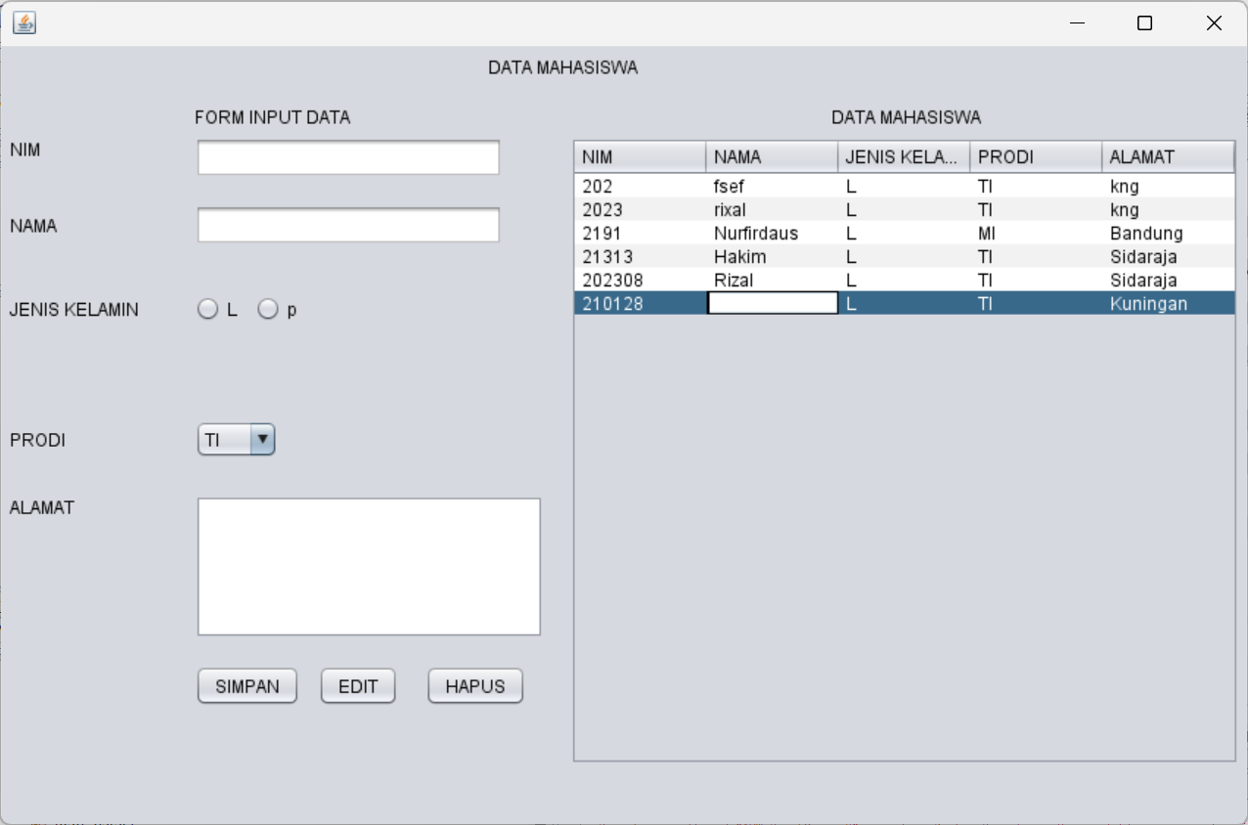
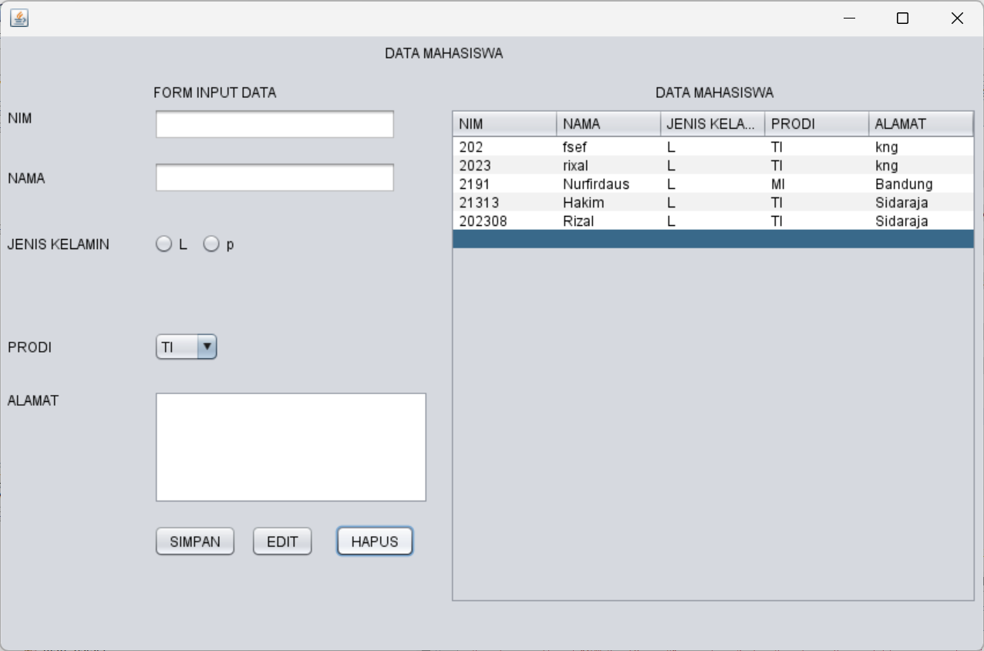
PostTest
- Lengkapi program, jika tombol Edit di klik akan menampilkan message dialog YesNoQuestion untuk edit data
- Lengkapi program, jika tombol Hapus di klik akan menampilkam message dialog YesNoQuestion untuk hapus data
- Lengkapi program, jika tombol Edit/Hapus di klik Form Input Data akan Kembali kosong seperti komdisi awal
- Setelah Edit/Hapus, maka JTable akan melakukan Load Data
/*
* To change this license header, choose License Headers in Project Properties.
* To change this template file, choose Tools | Templates
* and open the template in the editor.
*/

package bp1_m6_rizal;

import java.sql.ResultSet;
import java.sql.SQLException;
import java.sql.Statement;
import javax.swing.JOptionPane;
import javax.swing.table.DefaultTableModel;

/**
*
* @author Muhammad Rizal Nur F
*/
public class BP1_M6_P1_Rizal extends javax.swing.JFrame {
private Object JTable1;

Statement st;
ResultSet rs;
koneksi koneksi;

/**
* Creates new form BP1_M6_P1_Rizal
*/
public BP1_M6_P1_Rizal() {
koneksi = new koneksi();
initComponents();
load_data();
}
private void load_data() {
Object header[] = {"NIM", "NAMA", "JENIS KELAMIN", "PRODI", "ALAMAT"};
DefaultTableModel data = new DefaultTableModel(null, header);
jTable1.setModel(data);
String sql = "SELECT nim, nama, jk, prodi, alamat FROM tabel_mhs";
try {
st = koneksi.con.createStatement();
rs = st.executeQuery(sql);
while (rs.next()) {
String k1 = rs.getString("nim");
String k2 = rs.getString("nama");
String k3 = rs.getString("jk");
String k4 = rs.getString("prodi");
String k5 = rs.getString("alamat");

String k[] = {k1, k2, k3, k4, k5};
data.addRow(k);
}
} catch (Exception e) {
JOptionPane.showMessageDialog(null, e);
}
}

public void input_data() {
try {
// Validasi input: Pastikan semua data terisi
if (jTextField1.getText().isEmpty() ||
jTextField2.getText().isEmpty() ||
(!jRadioButton1.isSelected() && !jRadioButton2.isSelected()) ||
jTextArea1.getText().isEmpty()) {
JOptionPane.showMessageDialog(null, "Data Harus Diisi!", "Peringatan", JOptionPane.WARNING_MESSAGE);
return;
}

// Ambil nilai jenis kelamin
String jk = jRadioButton1.isSelected() ? jRadioButton1.getText() : jRadioButton2.getText();

// Konfirmasi penyimpanan data
int confirm = JOptionPane.showConfirmDialog(null, "Apakah Anda yakin ingin menyimpan data?", "Konfirmasi", JOptionPane.YES_NO_OPTION);
if (confirm == JOptionPane.YES_OPTION) {
String sql = "INSERT INTO tabel_mhs (nim, nama, jk, prodi, alamat) VALUES ('"
+ jTextField1.getText() + "', '"
+ jTextField2.getText() + "', '"
+ jk + "', '"
+ jComboBox1.getSelectedItem().toString() + "', '"
+ jTextArea1.getText() + "')";
st = koneksi.con.createStatement();
st.execute(sql);
JOptionPane.showMessageDialog(null, "Data Mahasiswa Berhasil Disimpan");

// Muat ulang data di tabel dan reset form
load_data();
reset_form();
}
} catch (SQLException e) {
JOptionPane.showMessageDialog(null, "Error: " + e.getMessage());
}
}

private void reset_form() {
jTextField1.setText("");
jTextField2.setText("");
jRadioButton1.setSelected(false);
jRadioButton2.setSelected(false);
jComboBox1.setSelectedIndex(0);
jTextArea1.setText("");
}

/**
* This method is called from within the constructor to initialize the form.
* WARNING: Do NOT modify this code. The content of this method is always
* regenerated by the Form Editor.
*/
@SuppressWarnings("unchecked")
// <editor-fold defaultstate="collapsed" desc="Generated Code">
private void initComponents() {

jLabel1 = new javax.swing.JLabel();
jLabel2 = new javax.swing.JLabel();
jLabel3 = new javax.swing.JLabel();
jLabel4 = new javax.swing.JLabel();
jLabel5 = new javax.swing.JLabel();
jLabel6 = new javax.swing.JLabel();
jLabel7 = new javax.swing.JLabel();
jLabel8 = new javax.swing.JLabel();
jTextField1 = new javax.swing.JTextField();
jTextField2 = new javax.swing.JTextField();
jRadioButton1 = new javax.swing.JRadioButton();
jRadioButton2 = new javax.swing.JRadioButton();
jComboBox1 = new javax.swing.JComboBox();
jScrollPane1 = new javax.swing.JScrollPane();
jTextArea1 = new javax.swing.JTextArea();
ButtonSimpan = new javax.swing.JButton();
jButton2 = new javax.swing.JButton();
jButton3 = new javax.swing.JButton();
jScrollPane2 = new javax.swing.JScrollPane();
jTable1 = new javax.swing.JTable();

setDefaultCloseOperation(javax.swing.WindowConstants.EXIT_ON_CLOSE);

jLabel1.setText("DATA MAHASISWA");

jLabel2.setText("FORM INPUT DATA ");

jLabel3.setText("DATA MAHASISWA");

jLabel4.setText("NIM");

jLabel5.setText("NAMA");

jLabel6.setText("JENIS KELAMIN");

jLabel7.setText("PRODI");

jLabel8.setText("ALAMAT");

jTextField1.addActionListener(new java.awt.event.ActionListener() {
public void actionPerformed(java.awt.event.ActionEvent evt) {
jTextField1ActionPerformed(evt);
}
});

jRadioButton1.setText("L");

jRadioButton2.setText("p");

jComboBox1.setModel(new javax.swing.DefaultComboBoxModel(new String[] { "TI", "SI", "DKV", "MI", "TS" }));

jTextArea1.setColumns(20);
jTextArea1.setRows(5);
jScrollPane1.setViewportView(jTextArea1);

ButtonSimpan.setText("SIMPAN");
ButtonSimpan.addActionListener(new java.awt.event.ActionListener() {
public void actionPerformed(java.awt.event.ActionEvent evt) {
ButtonSimpanActionPerformed(evt);
}
});

jButton2.setText("EDIT");
jButton2.addMouseListener(new java.awt.event.MouseAdapter() {
public void mouseClicked(java.awt.event.MouseEvent evt) {
jButton2MouseClicked(evt);
}
});

jButton3.setText("HAPUS");
jButton3.addMouseListener(new java.awt.event.MouseAdapter() {
public void mouseClicked(java.awt.event.MouseEvent evt) {
jButton3MouseClicked(evt);
}
});

jTable1.setModel(new javax.swing.table.DefaultTableModel(
new Object [][] {
{null, null, null, null},
{null, null, null, null},
{null, null, null, null},
{null, null, null, null}
},
new String [] {
"Title 1", "Title 2", "Title 3", "Title 4"
}
));
jScrollPane2.setViewportView(jTable1);

javax.swing.GroupLayout layout = new javax.swing.GroupLayout(getContentPane());
getContentPane().setLayout(layout);
layout.setHorizontalGroup(
layout.createParallelGroup(javax.swing.GroupLayout.Alignment.LEADING)
.addGroup(layout.createSequentialGroup()
.addContainerGap()
.addGroup(layout.createParallelGroup(javax.swing.GroupLayout.Alignment.LEADING)
.addGroup(layout.createSequentialGroup()
.addGroup(layout.createParallelGroup(javax.swing.GroupLayout.Alignment.LEADING)
.addComponent(jLabel4)
.addComponent(jLabel5)
.addComponent(jLabel6)
.addComponent(jLabel7)
.addComponent(jLabel8))
.addGap(38, 38, 38)
.addGroup(layout.createParallelGroup(javax.swing.GroupLayout.Alignment.LEADING)
.addGroup(layout.createParallelGroup(javax.swing.GroupLayout.Alignment.LEADING, false)
.addComponent(jTextField1)
.addComponent(jTextField2, javax.swing.GroupLayout.DEFAULT_SIZE, 210, Short.MAX_VALUE))
.addComponent(jLabel2)
.addGroup(layout.createSequentialGroup()
.addComponent(jRadioButton1)
.addPreferredGap(javax.swing.LayoutStyle.ComponentPlacement.UNRELATED)
.addComponent(jRadioButton2))
.addComponent(jComboBox1, javax.swing.GroupLayout.PREFERRED_SIZE, javax.swing.GroupLayout.DEFAULT_SIZE, javax.swing.GroupLayout.PREFERRED_SIZE)
.addComponent(jScrollPane1, javax.swing.GroupLayout.PREFERRED_SIZE, javax.swing.GroupLayout.DEFAULT_SIZE, javax.swing.GroupLayout.PREFERRED_SIZE)
.addGroup(layout.createSequentialGroup()
.addComponent(ButtonSimpan)
.addPreferredGap(javax.swing.LayoutStyle.ComponentPlacement.UNRELATED)
.addComponent(jButton2)
.addGap(18, 18, 18)
.addComponent(jButton3)))
.addGroup(layout.createParallelGroup(javax.swing.GroupLayout.Alignment.LEADING)
.addGroup(layout.createSequentialGroup()
.addPreferredGap(javax.swing.LayoutStyle.ComponentPlacement.RELATED, javax.swing.GroupLayout.DEFAULT_SIZE, Short.MAX_VALUE)
.addComponent(jLabel3)
.addGap(188, 188, 188))
.addGroup(layout.createSequentialGroup()
.addGap(18, 18, 18)
.addComponent(jScrollPane2, javax.swing.GroupLayout.PREFERRED_SIZE, javax.swing.GroupLayout.DEFAULT_SIZE, javax.swing.GroupLayout.PREFERRED_SIZE)
.addContainerGap(javax.swing.GroupLayout.DEFAULT_SIZE, Short.MAX_VALUE))))
.addGroup(javax.swing.GroupLayout.Alignment.TRAILING, layout.createSequentialGroup()
.addGap(0, 0, Short.MAX_VALUE)
.addComponent(jLabel1)
.addGap(422, 422, 422))))
);
layout.setVerticalGroup(
layout.createParallelGroup(javax.swing.GroupLayout.Alignment.LEADING)
.addGroup(layout.createSequentialGroup()
.addContainerGap()
.addComponent(jLabel1)
.addGap(18, 18, 18)
.addGroup(layout.createParallelGroup(javax.swing.GroupLayout.Alignment.BASELINE)
.addComponent(jLabel2)
.addComponent(jLabel3))
.addPreferredGap(javax.swing.LayoutStyle.ComponentPlacement.RELATED)
.addGroup(layout.createParallelGroup(javax.swing.GroupLayout.Alignment.LEADING)
.addGroup(layout.createSequentialGroup()
.addGroup(layout.createParallelGroup(javax.swing.GroupLayout.Alignment.LEADING)
.addComponent(jLabel4)
.addComponent(jTextField1, javax.swing.GroupLayout.PREFERRED_SIZE, javax.swing.GroupLayout.DEFAULT_SIZE, javax.swing.GroupLayout.PREFERRED_SIZE))
.addGap(18, 18, 18)
.addGroup(layout.createParallelGroup(javax.swing.GroupLayout.Alignment.BASELINE)
.addComponent(jLabel5)
.addComponent(jTextField2, javax.swing.GroupLayout.PREFERRED_SIZE, javax.swing.GroupLayout.DEFAULT_SIZE, javax.swing.GroupLayout.PREFERRED_SIZE))
.addGap(34, 34, 34)
.addGroup(layout.createParallelGroup(javax.swing.GroupLayout.Alignment.BASELINE)
.addComponent(jLabel6)
.addComponent(jRadioButton1)
.addComponent(jRadioButton2))
.addGap(67, 67, 67)
.addGroup(layout.createParallelGroup(javax.swing.GroupLayout.Alignment.BASELINE)
.addComponent(jLabel7)
.addComponent(jComboBox1, javax.swing.GroupLayout.PREFERRED_SIZE, javax.swing.GroupLayout.DEFAULT_SIZE, javax.swing.GroupLayout.PREFERRED_SIZE))
.addGap(25, 25, 25)
.addGroup(layout.createParallelGroup(javax.swing.GroupLayout.Alignment.LEADING)
.addComponent(jLabel8)
.addComponent(jScrollPane1, javax.swing.GroupLayout.PREFERRED_SIZE, javax.swing.GroupLayout.DEFAULT_SIZE, javax.swing.GroupLayout.PREFERRED_SIZE))
.addGap(18, 18, 18)
.addGroup(layout.createParallelGroup(javax.swing.GroupLayout.Alignment.BASELINE)
.addComponent(ButtonSimpan)
.addComponent(jButton2)
.addComponent(jButton3)))
.addComponent(jScrollPane2, javax.swing.GroupLayout.PREFERRED_SIZE, javax.swing.GroupLayout.DEFAULT_SIZE, javax.swing.GroupLayout.PREFERRED_SIZE))
.addContainerGap(41, Short.MAX_VALUE))
);

pack();
}// </editor-fold>

private void jTextField1ActionPerformed(java.awt.event.ActionEvent evt) {
// TODO add your handling code here:
}

private void ButtonSimpanActionPerformed(java.awt.event.ActionEvent evt) {
// TODO add your handling code here:
input_data();
}

private void jButton2MouseClicked(java.awt.event.MouseEvent evt) {
// TODO add your handling code here:
// Button Edit
try {
int confirm = JOptionPane.showConfirmDialog(null, "Apakah Anda yakin ingin mengedit data?", "Konfirmasi Edit", JOptionPane.YES_NO_OPTION);
if (confirm == JOptionPane.YES_OPTION) {
String jk = jRadioButton1.isSelected() ? jRadioButton1.getText() : jRadioButton2.getText();

String sql_edit = "UPDATE tabel_mhs SET nama = '"
+ jTextField2.getText()
+ "', jk = '" + jk
+ "', prodi = '" + jComboBox1.getSelectedItem().toString()
+ "', alamat = '" + jTextArea1.getText()
+ "' WHERE nim = '" + jTextField1.getText() + "'";
st.executeUpdate(sql_edit);
JOptionPane.showMessageDialog(null, "Data Mahasiswa Berhasil Diupdate");

// Muat ulang data di tabel dan reset form
load_data();
reset_form();
}
} catch (SQLException e) {
JOptionPane.showMessageDialog(null, "Error: " + e.getMessage());
}

}

private void jButton3MouseClicked(java.awt.event.MouseEvent evt) {
// TODO add your handling code here:
// Button Hapus
try {
int confirm = JOptionPane.showConfirmDialog(null, "Apakah Anda yakin ingin menghapus data?", "Konfirmasi Hapus", JOptionPane.YES_NO_OPTION);
if (confirm == JOptionPane.YES_OPTION) {
String sql_delete = "DELETE FROM tabel_mhs WHERE nim = '" + jTextField1.getText() + "'";
st.executeUpdate(sql_delete);
JOptionPane.showMessageDialog(null, "Data Mahasiswa Berhasil Dihapus");

// Muat ulang data di tabel dan reset form
load_data();
reset_form();
}
} catch (SQLException e) {
JOptionPane.showMessageDialog(null, "Error: " + e.getMessage());
}
}

/**
* @param args the command line arguments
*/
public static void main(String args[]) {
/* Set the Nimbus look and feel */
//<editor-fold defaultstate="collapsed" desc=" Look and feel setting code (optional) ">
/* If Nimbus (introduced in Java SE 6) is not available, stay with the default look and feel.
* For details see http://download.oracle.com/javase/tutorial/uiswing/lookandfeel/plaf.html
*/
try {
for (javax.swing.UIManager.LookAndFeelInfo info : javax.swing.UIManager.getInstalledLookAndFeels()) {
if ("Nimbus".equals(info.getName())) {
javax.swing.UIManager.setLookAndFeel(info.getClassName());
break;
}
}
} catch (ClassNotFoundException ex) {
java.util.logging.Logger.getLogger(BP1_M6_P1_Rizal.class.getName()).log(java.util.logging.Level.SEVERE, null, ex);
} catch (InstantiationException ex) {
java.util.logging.Logger.getLogger(BP1_M6_P1_Rizal.class.getName()).log(java.util.logging.Level.SEVERE, null, ex);
} catch (IllegalAccessException ex) {
java.util.logging.Logger.getLogger(BP1_M6_P1_Rizal.class.getName()).log(java.util.logging.Level.SEVERE, null, ex);
} catch (javax.swing.UnsupportedLookAndFeelException ex) {
java.util.logging.Logger.getLogger(BP1_M6_P1_Rizal.class.getName()).log(java.util.logging.Level.SEVERE, null, ex);
}
//</editor-fold>

/* Create and display the form */
java.awt.EventQueue.invokeLater(new Runnable() {
public void run() {
new BP1_M6_P1_Rizal().setVisible(true);
}
});
}

// Variables declaration - do not modify
private javax.swing.JButton ButtonSimpan;
private javax.swing.JButton jButton2;
private javax.swing.JButton jButton3;
private javax.swing.JComboBox jComboBox1;
private javax.swing.JLabel jLabel1;
private javax.swing.JLabel jLabel2;
private javax.swing.JLabel jLabel3;
private javax.swing.JLabel jLabel4;
private javax.swing.JLabel jLabel5;
private javax.swing.JLabel jLabel6;
private javax.swing.JLabel jLabel7;
private javax.swing.JLabel jLabel8;
private javax.swing.JRadioButton jRadioButton1;
private javax.swing.JRadioButton jRadioButton2;
private javax.swing.JScrollPane jScrollPane1;
private javax.swing.JScrollPane jScrollPane2;
private javax.swing.JTable jTable1;
private javax.swing.JTextArea jTextArea1;
private javax.swing.JTextField jTextField1;
private javax.swing.JTextField jTextField2;
// End of variables declaration
}
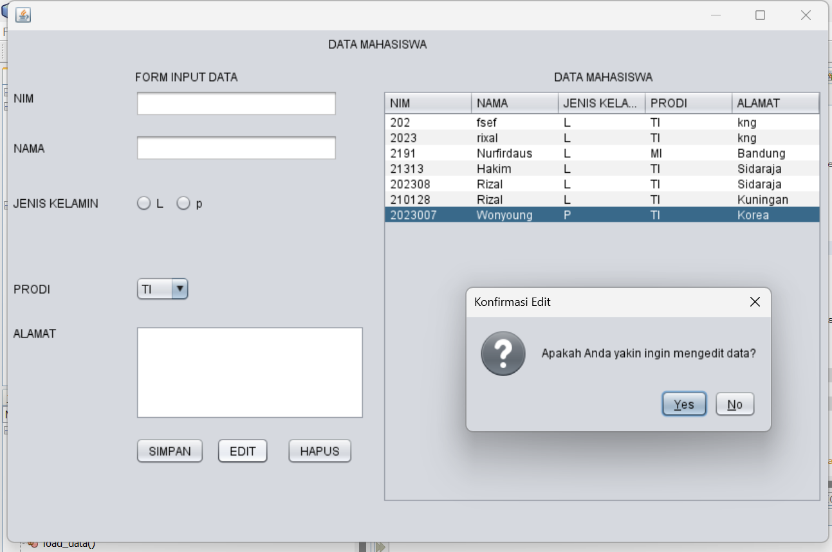
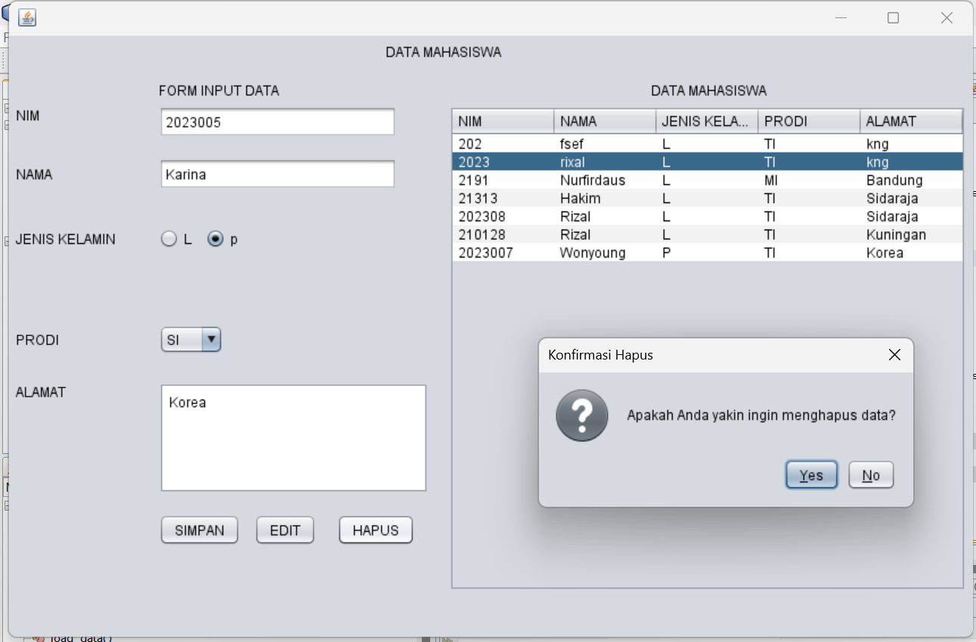
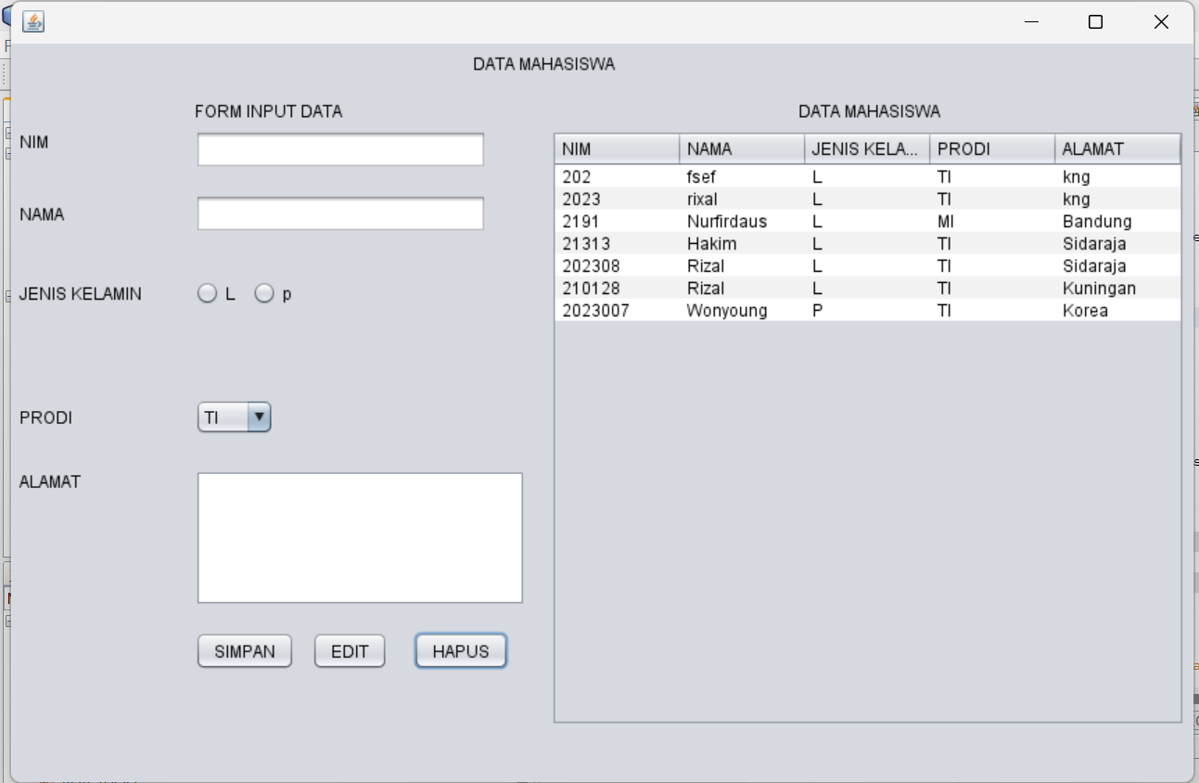
Analisis : Program ini mengelola data mahasiswa dengan fitur CRUD (Create, Read, Update, Delete) yang dilengkapi konfirmasi dialog untuk aksi Edit dan Hapus. Setiap perubahan data disertai validasi dan interaksi pengguna melalui dialog Yes/No Question untuk memastikan tindakan. Setelah operasi Edit atau Hapus berhasil, form input dikosongkan ke kondisi awal menggunakan metode reset_form(), dan tabel diperbarui secara otomatis dengan memanggil load_data(). Implementasi ini memastikan integritas data, kemudahan pemakaian, dan responsif terhadap tindakan pengguna dalam pengelolaan data mahasiswa.
Tugas
- Buat Form Data Mata Kuliah dan Data Nilai (Tugas,
- Buat table baru (mk dan nilai) di database yang sudah dibuat pada modul 6
- Lengkapi CRUD pada masing-masing Form (no.1)
/*
* To change this license header, choose License Headers in Project Properties.
* To change this template file, choose Tools | Templates
* and open the template in the editor.
*/

package bp1_m6_rizal;

import java.sql.ResultSet;
import java.sql.SQLException;
import java.sql.Statement;
import javax.swing.JOptionPane;
import javax.swing.table.DefaultTableModel;

/**
*
* @author Muhammad Rizal Nur F
*/
public class BP1_M8_T1_Rizal extends javax.swing.JFrame {
private Object JTable1;

Statement st;
ResultSet rs;
koneksi koneksi;

/**
* Creates new form BP1_M6_P1_Rizal
*/
public BP1_M8_T1_Rizal() {
koneksi = new koneksi();
initComponents();
load_data();
}
private void load_data() {
Object header[] = {"MATA KULIAH", "NILAI"};
DefaultTableModel data = new DefaultTableModel(null, header);
jTable1.setModel(data);
String sql = "SELECT mata_kuliah, nilai FROM tabel_mkdannilai";
try {
st = koneksi.con.createStatement();
rs = st.executeQuery(sql);
while (rs.next()) {
String k1 = rs.getString("mata_kuliah");
String k2 = rs.getString("nilai");

String k[] = {k1, k2};
data.addRow(k);
}
} catch (Exception e) {
JOptionPane.showMessageDialog(null, e);
}
}

public void input_data() {
try {
// Validasi input
if (jTextField1.getText().isEmpty() || jTextField2.getText().isEmpty()) {
JOptionPane.showMessageDialog(null, "Data Mata Kuliah dan Nilai harus diisi!", "Peringatan", JOptionPane.WARNING_MESSAGE);
return;
}

String sql = "INSERT INTO tabel_mkdannilai (mata_kuliah, nilai) VALUES ('"
+ jTextField1.getText() + "', '"
+ jTextField2.getText() + "')";
st = koneksi.con.createStatement();
st.execute(sql);
JOptionPane.showMessageDialog(null, "Data Berhasil Disimpan");

load_data();
reset_form();
} catch (SQLException e) {
JOptionPane.showMessageDialog(null, "Error: " + e.getMessage());
}
}

public void edit_data() {
try {
if (jTable1.getSelectedRow() == -1) {
JOptionPane.showMessageDialog(null, "Pilih data yang akan diubah!", "Peringatan", JOptionPane.WARNING_MESSAGE);
return;
}

String mataKuliah = jTextField1.getText();
String nilai = jTextField2.getText();
String sql = "UPDATE tabel_mkdannilai SET nilai = '" + nilai + "' WHERE mata_kuliah = '" + mataKuliah + "'";
st = koneksi.con.createStatement();
st.executeUpdate(sql);
JOptionPane.showMessageDialog(null, "Data Berhasil Diperbarui");

load_data();
reset_form();
} catch (SQLException e) {
JOptionPane.showMessageDialog(null, "Error: " + e.getMessage());
}
}

public void hapus_data() {
try {
if (jTable1.getSelectedRow() == -1) {
JOptionPane.showMessageDialog(null, "Pilih data yang akan dihapus!", "Peringatan", JOptionPane.WARNING_MESSAGE);
return;
}

int confirm = JOptionPane.showConfirmDialog(null, "Apakah Anda yakin ingin menghapus data?", "Konfirmasi", JOptionPane.YES_NO_OPTION);
if (confirm == JOptionPane.YES_OPTION) {
String mataKuliah = jTable1.getValueAt(jTable1.getSelectedRow(), 0).toString();
String sql = "DELETE FROM tabel_mkdannilai WHERE mata_kuliah = '" + mataKuliah + "'";
st = koneksi.con.createStatement();
st.executeUpdate(sql);
JOptionPane.showMessageDialog(null, "Data Berhasil Dihapus");

load_data();
}
} catch (SQLException e) {
JOptionPane.showMessageDialog(null, "Error: " + e.getMessage());
}
}

private void reset_form() {
jTextField1.setText("");
jTextField2.setText("");
}

/**
* This method is called from within the constructor to initialize the form.
* WARNING: Do NOT modify this code. The content of this method is always
* regenerated by the Form Editor.
*/
@SuppressWarnings("unchecked")
// <editor-fold defaultstate="collapsed" desc="Generated Code">
private void initComponents() {

jLabel1 = new javax.swing.JLabel();
jLabel2 = new javax.swing.JLabel();
jLabel3 = new javax.swing.JLabel();
jLabel4 = new javax.swing.JLabel();
jLabel5 = new javax.swing.JLabel();
jTextField1 = new javax.swing.JTextField();
jTextField2 = new javax.swing.JTextField();
ButtonSimpan = new javax.swing.JButton();
jButton2 = new javax.swing.JButton();
jButton3 = new javax.swing.JButton();
jScrollPane2 = new javax.swing.JScrollPane();
jTable1 = new javax.swing.JTable();

setDefaultCloseOperation(javax.swing.WindowConstants.EXIT_ON_CLOSE);

jLabel1.setText("DATA MATA KULIAH DAN NILAI");

jLabel2.setText("FORM INPUT DATA ");

jLabel3.setText("DATA MATA KULIAH DAN NILAI");

jLabel4.setText("MATA KULIAH");

jLabel5.setText("NILAI");

jTextField1.addActionListener(new java.awt.event.ActionListener() {
public void actionPerformed(java.awt.event.ActionEvent evt) {
jTextField1ActionPerformed(evt);
}
});

ButtonSimpan.setText("SIMPAN");
ButtonSimpan.addActionListener(new java.awt.event.ActionListener() {
public void actionPerformed(java.awt.event.ActionEvent evt) {
ButtonSimpanActionPerformed(evt);
}
});

jButton2.setText("EDIT");
jButton2.addMouseListener(new java.awt.event.MouseAdapter() {
public void mouseClicked(java.awt.event.MouseEvent evt) {
jButton2MouseClicked(evt);
}
});

jButton3.setText("HAPUS");
jButton3.addMouseListener(new java.awt.event.MouseAdapter() {
public void mouseClicked(java.awt.event.MouseEvent evt) {
jButton3MouseClicked(evt);
}
});

jTable1.setModel(new javax.swing.table.DefaultTableModel(
new Object [][] {
{null, null, null, null},
{null, null, null, null},
{null, null, null, null},
{null, null, null, null}
},
new String [] {
"Title 1", "Title 2", "Title 3", "Title 4"
}
));
jScrollPane2.setViewportView(jTable1);

javax.swing.GroupLayout layout = new javax.swing.GroupLayout(getContentPane());
getContentPane().setLayout(layout);
layout.setHorizontalGroup(
layout.createParallelGroup(javax.swing.GroupLayout.Alignment.LEADING)
.addGroup(layout.createSequentialGroup()
.addContainerGap()
.addGroup(layout.createParallelGroup(javax.swing.GroupLayout.Alignment.LEADING)
.addComponent(jLabel4)
.addComponent(jLabel5))
.addGap(106, 106, 106)
.addGroup(layout.createParallelGroup(javax.swing.GroupLayout.Alignment.LEADING)
.addGroup(layout.createParallelGroup(javax.swing.GroupLayout.Alignment.LEADING, false)
.addComponent(jTextField1)
.addComponent(jTextField2, javax.swing.GroupLayout.DEFAULT_SIZE, 210, Short.MAX_VALUE))
.addComponent(jLabel2)
.addGroup(layout.createSequentialGroup()
.addComponent(ButtonSimpan)
.addPreferredGap(javax.swing.LayoutStyle.ComponentPlacement.RELATED)
.addComponent(jButton2)
.addPreferredGap(javax.swing.LayoutStyle.ComponentPlacement.RELATED)
.addComponent(jButton3)))
.addGap(33, 33, 33)
.addGroup(layout.createParallelGroup(javax.swing.GroupLayout.Alignment.LEADING)
.addGroup(layout.createSequentialGroup()
.addComponent(jLabel3)
.addGap(188, 188, 188))
.addGroup(layout.createSequentialGroup()
.addComponent(jScrollPane2, javax.swing.GroupLayout.PREFERRED_SIZE, javax.swing.GroupLayout.DEFAULT_SIZE, javax.swing.GroupLayout.PREFERRED_SIZE)
.addContainerGap(javax.swing.GroupLayout.DEFAULT_SIZE, Short.MAX_VALUE))))
.addGroup(layout.createSequentialGroup()
.addGap(320, 320, 320)
.addComponent(jLabel1)
.addGap(0, 0, Short.MAX_VALUE))
);
layout.setVerticalGroup(
layout.createParallelGroup(javax.swing.GroupLayout.Alignment.LEADING)
.addGroup(layout.createSequentialGroup()
.addGap(18, 18, 18)
.addComponent(jLabel1)
.addPreferredGap(javax.swing.LayoutStyle.ComponentPlacement.UNRELATED)
.addGroup(layout.createParallelGroup(javax.swing.GroupLayout.Alignment.BASELINE)
.addComponent(jLabel2)
.addComponent(jLabel3))
.addPreferredGap(javax.swing.LayoutStyle.ComponentPlacement.RELATED)
.addGroup(layout.createParallelGroup(javax.swing.GroupLayout.Alignment.LEADING)
.addGroup(layout.createSequentialGroup()
.addGroup(layout.createParallelGroup(javax.swing.GroupLayout.Alignment.LEADING)
.addComponent(jLabel4)
.addComponent(jTextField1, javax.swing.GroupLayout.PREFERRED_SIZE, javax.swing.GroupLayout.DEFAULT_SIZE, javax.swing.GroupLayout.PREFERRED_SIZE))
.addGap(18, 18, 18)
.addGroup(layout.createParallelGroup(javax.swing.GroupLayout.Alignment.BASELINE)
.addComponent(jLabel5)
.addComponent(jTextField2, javax.swing.GroupLayout.PREFERRED_SIZE, javax.swing.GroupLayout.DEFAULT_SIZE, javax.swing.GroupLayout.PREFERRED_SIZE))
.addGap(51, 51, 51)
.addGroup(layout.createParallelGroup(javax.swing.GroupLayout.Alignment.BASELINE)
.addComponent(ButtonSimpan)
.addComponent(jButton2)
.addComponent(jButton3)))
.addComponent(jScrollPane2, javax.swing.GroupLayout.PREFERRED_SIZE, javax.swing.GroupLayout.DEFAULT_SIZE, javax.swing.GroupLayout.PREFERRED_SIZE))
.addContainerGap(41, Short.MAX_VALUE))
);

pack();
}// </editor-fold>

private void jTextField1ActionPerformed(java.awt.event.ActionEvent evt) {
// TODO add your handling code here:
}

private void jButton3MouseClicked(java.awt.event.MouseEvent evt) {
// TODO add your handling code here:
// Button Hapus
try {
st = koneksi.con.createStatement();
String sql_delete = "DELETE FROM tabel_mkdannilai WHERE mata_kuliah='" + jTextField1.getText() + "'";
st.executeUpdate(sql_delete);
JOptionPane.showMessageDialog(null, "Data berhasil dihapus!");
load_data(); // Muat ulang tabel
reset_form(); // Reset form
} catch (SQLException e) {
JOptionPane.showMessageDialog(null, "Error: " + e.getMessage());
}

}

private void jButton2MouseClicked(java.awt.event.MouseEvent evt) {
// TODO add your handling code here:
// Button Edit
try {
String sql_edit = "UPDATE tabel_mkdannilai SET nilai = '" + jTextField2.getText()
+ "' WHERE mata_kuliah = '" + jTextField1.getText() + "'";
st = koneksi.con.createStatement();
st.executeUpdate(sql_edit);
JOptionPane.showMessageDialog(null, "Data berhasil diperbarui!");
load_data(); // Muat ulang tabel
reset_form(); // Reset form
} catch (SQLException e) {
JOptionPane.showMessageDialog(null, "Error: " + e.getMessage());
}

}

private void ButtonSimpanActionPerformed(java.awt.event.ActionEvent evt) {
// TODO add your handling code here:
input_data();
}

/**
* @param args the command line arguments
*/
public static void main(String args[]) {
/* Set the Nimbus look and feel */
//<editor-fold defaultstate="collapsed" desc=" Look and feel setting code (optional) ">
/* If Nimbus (introduced in Java SE 6) is not available, stay with the default look and feel.
* For details see http://download.oracle.com/javase/tutorial/uiswing/lookandfeel/plaf.html
*/
try {
for (javax.swing.UIManager.LookAndFeelInfo info : javax.swing.UIManager.getInstalledLookAndFeels()) {
if ("Nimbus".equals(info.getName())) {
javax.swing.UIManager.setLookAndFeel(info.getClassName());
break;
}
}
} catch (ClassNotFoundException ex) {
java.util.logging.Logger.getLogger(BP1_M6_P1_Rizal.class.getName()).log(java.util.logging.Level.SEVERE, null, ex);
} catch (InstantiationException ex) {
java.util.logging.Logger.getLogger(BP1_M6_P1_Rizal.class.getName()).log(java.util.logging.Level.SEVERE, null, ex);
} catch (IllegalAccessException ex) {
java.util.logging.Logger.getLogger(BP1_M6_P1_Rizal.class.getName()).log(java.util.logging.Level.SEVERE, null, ex);
} catch (javax.swing.UnsupportedLookAndFeelException ex) {
java.util.logging.Logger.getLogger(BP1_M6_P1_Rizal.class.getName()).log(java.util.logging.Level.SEVERE, null, ex);
}
//</editor-fold>

/* Create and display the form */
java.awt.EventQueue.invokeLater(new Runnable() {
public void run() {
new BP1_M8_T1_Rizal().setVisible(true);
}
});
}

// Variables declaration - do not modify
private javax.swing.JButton ButtonSimpan;
private javax.swing.JButton jButton2;
private javax.swing.JButton jButton3;
private javax.swing.JLabel jLabel1;
private javax.swing.JLabel jLabel2;
private javax.swing.JLabel jLabel3;
private javax.swing.JLabel jLabel4;
private javax.swing.JLabel jLabel5;
private javax.swing.JScrollPane jScrollPane2;
private javax.swing.JTable jTable1;
private javax.swing.JTextField jTextField1;
private javax.swing.JTextField jTextField2;
// End of variables declaration
}
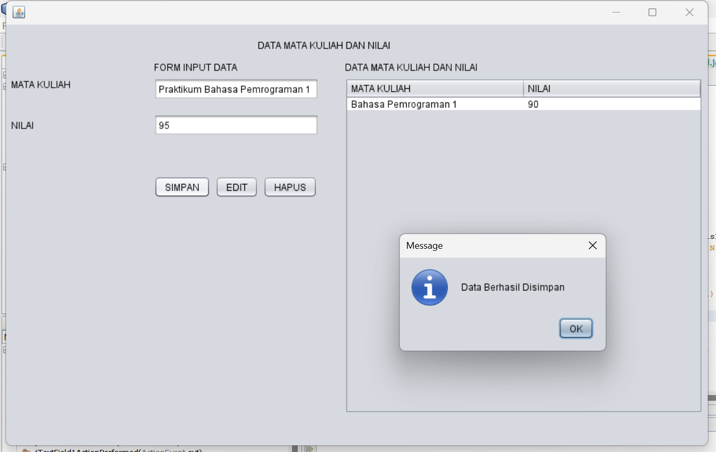
Analisis : Kode diatas bertujuan untuk menyimpan, mengedit, dan menghapus data mata kuliah dan nilai pada tabel telah berhasil disesuaikan dengan kebutuhan. Fungsi penyimpanan memastikan data dimasukkan ke tabel dengan format yang benar, termasuk validasi input untuk mencegah data kosong. Fungsi pengeditan memodifikasi data berdasarkan mata kuliah yang dipilih, dan fungsi penghapusan memastikan data yang spesifik dihapus dari tabel. Semua interaksi dengan database menggunakan perintah SQL yang sesuai, sementara tabel di GUI diperbarui secara dinamis untuk mencerminkan perubahan data. Solusi ini sudah mencakup validasi dan integrasi yang baik antara antarmuka pengguna dan database, sehingga dapat digunakan dengan lancar untuk pengelolaan data mata kuliah dan nilai.
- Buat Form Data Nilai Mahasiswa, yang menampilkan NIM, NAMA, JK, PRODI, KELAS, NILAI, PHOTO
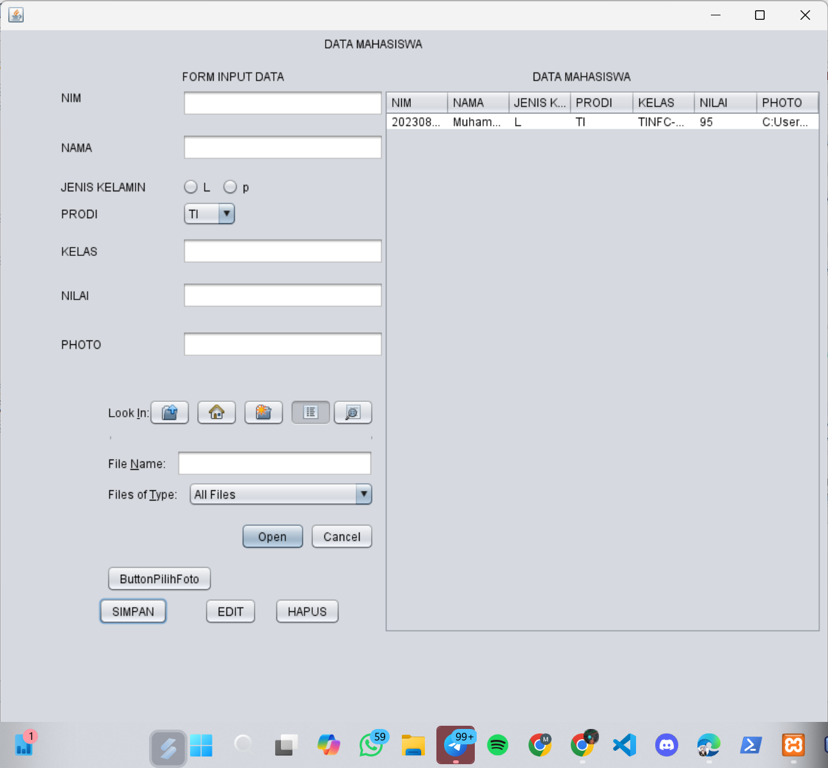
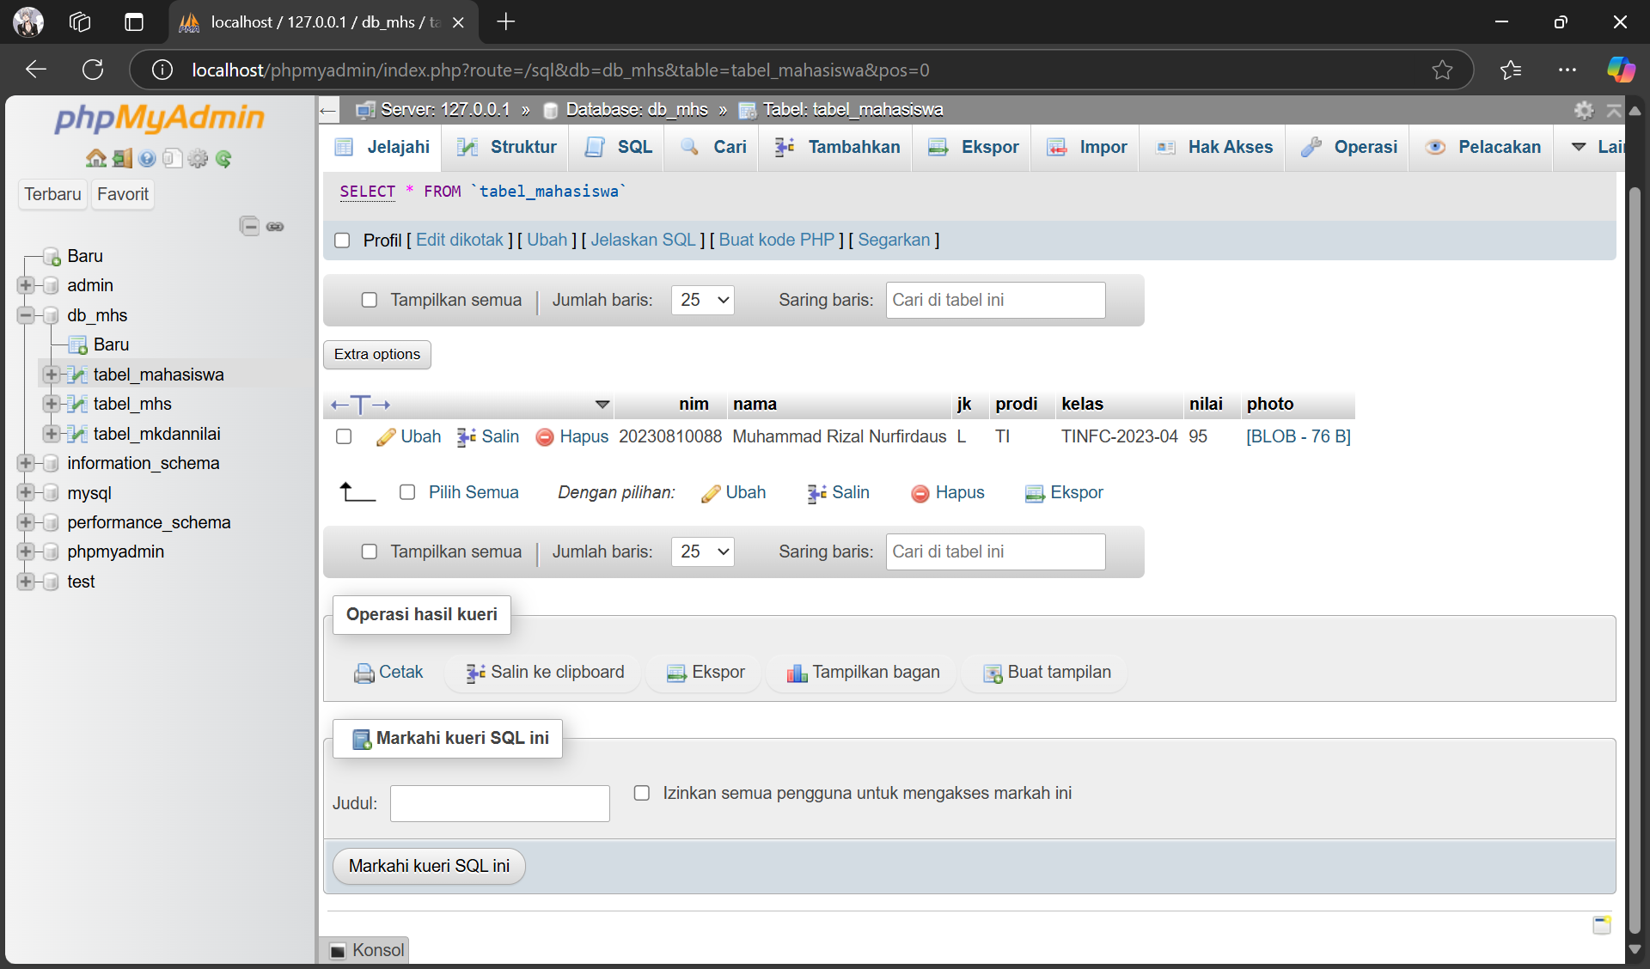

Analisis : Aplikasi ini merupakan program pengelolaan data mahasiswa berbasis GUI (Graphical User Interface) yang dibuat menggunakan Java Swing. Tampilannya memiliki dua panel utama: formulir input data di sebelah kiri dan tabel untuk menampilkan data mahasiswa di sebelah kanan. Formulir input berisi beberapa field, seperti NIM, NAMA, JENIS KELAMIN, PRODI, KELAS, NILAI, dan PHOTO, dengan tambahan fungsi untuk memilih file foto melalui tombol ButtonPilihFoto. Di bagian bawah formulir terdapat tiga tombol utama: SIMPAN, EDIT, dan HAPUS, yang berfungsi untuk mengelola data pada tabel. Pada tabel, terdapat kolom NIM, NAMA, JENIS KELAMIN, PRODI, KELAS, NILAI, dan PHOTO yang berisi data mahasiswa yang sudah diinput. Aplikasi ini mempermudah manajemen data mahasiswa dengan fitur input, edit, dan hapus yang terintegrasi dalam antarmuka sederhana.

